# Work in Progress Documentation

Cleckhudderfax Online Megastore

**Team Name: Team A**

**Project Manager: Rohit Pandey**

***Team Members***

Dikson Rajbanshi (Team Leader)

Prasansa Dahal

Surya Shrestha

Susan Khatri

Alok Raj

# Overview

Cleckhudderfax Online Megastore is an online grocery store, which is being developed as a solution to the competition given by the national chains to the small local independent businesses at Cleckhudderfax. Given the fact that currently we are living in the information age where technologies are blooming, online markets are growing widely due to ease of use and better accessibility. Cleckhudderfax Online Megastore aims to be the solution for tackling the current issue at hand and provide the local shops with wider range of usage along with providing the customers with better shopping experience.

Table of Contents

Work in Progress Documentation 1

Overview 2

Product Initiation 5

Project Charter 5

Team Contract 8

Project Planning 12

Belbin Analysis (Team) 12

Belbin Analysis (Individual) 20

Skill Audit (Team) 22

Skill Audit (Individual) 23

Microsoft Project 24

Task Sheet 24

Gantt Chart 29

Calendar 33

Network Diagram 34

Resource Sheet 37

Team Meetings 38

Communication and Collaboration Tools Used 41

Trello 41

Slack 41

GitHub 42

Project Execution 43

Requirements 43

Entity Relationship Diagram (ERD) 47

Extended Entity Relationship Diagram (EERD) 48

Composite ERD 49

Logical Design 50

Use Case 51

Wireframes 53

Homepage 53

About Us 54

Shop 55

Single Product Page 56

Search 57

Basket Overview 59

Customer Profile 60

Website Work in Progress 61

Homepage 61

Login 62

# Product Initiation

## Project Charter

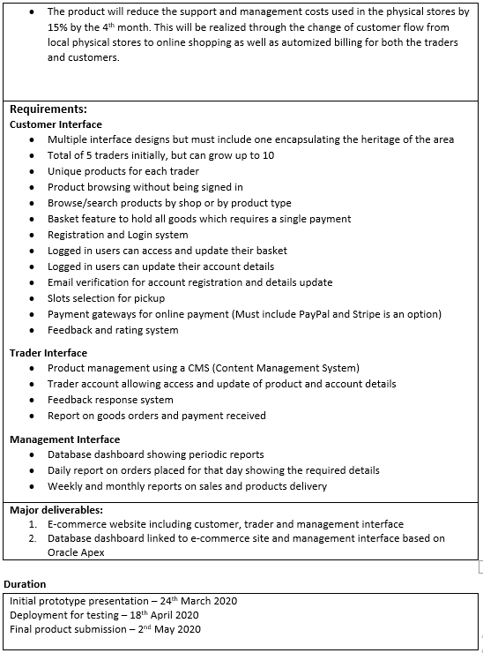

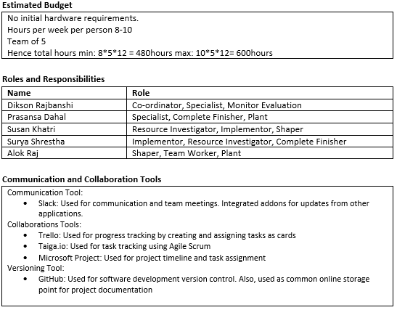

## Team Contract

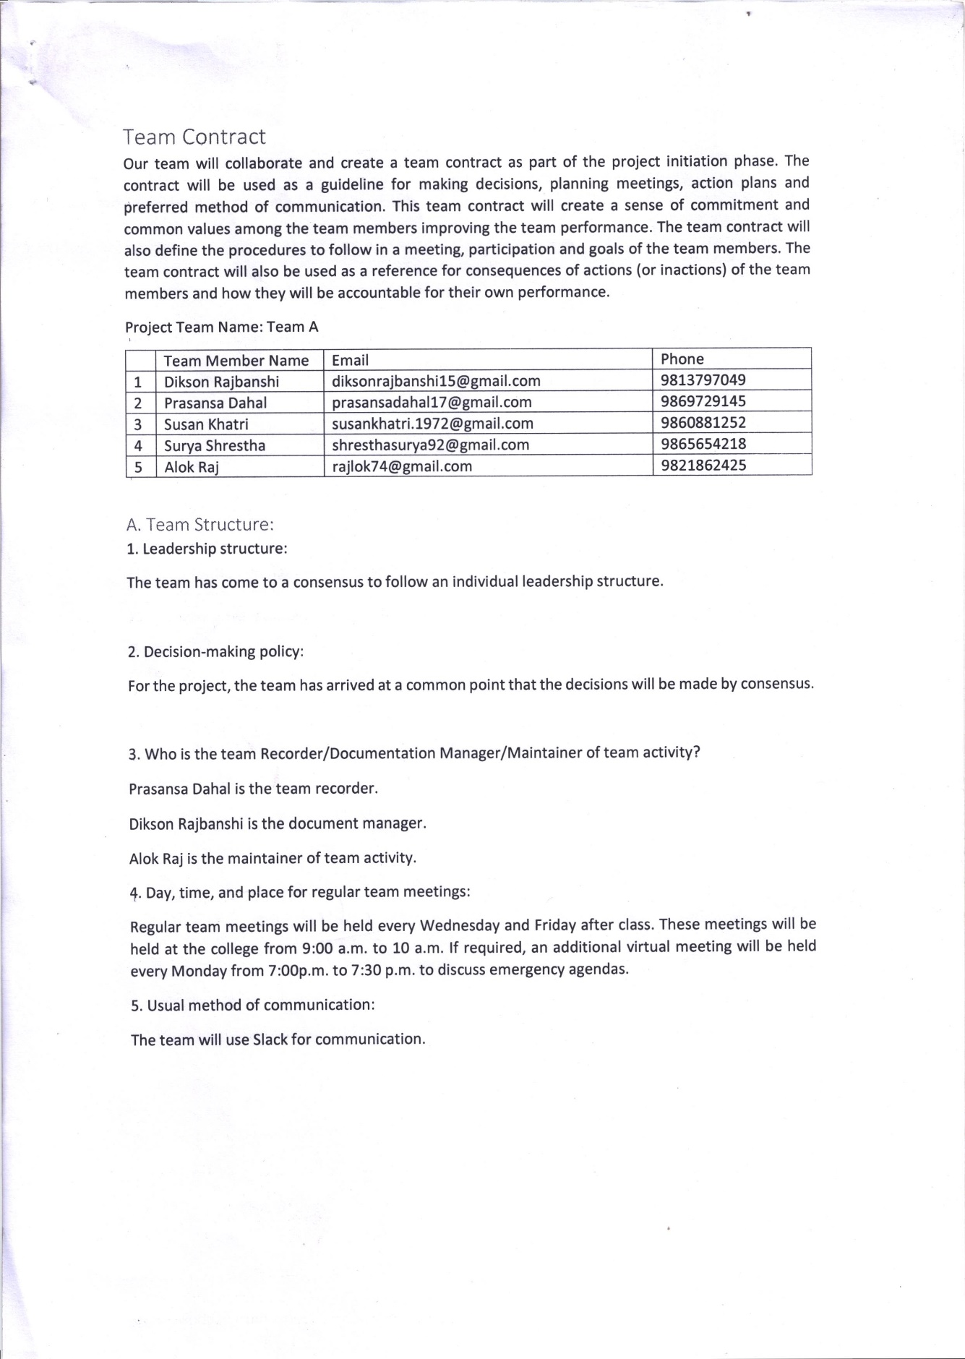

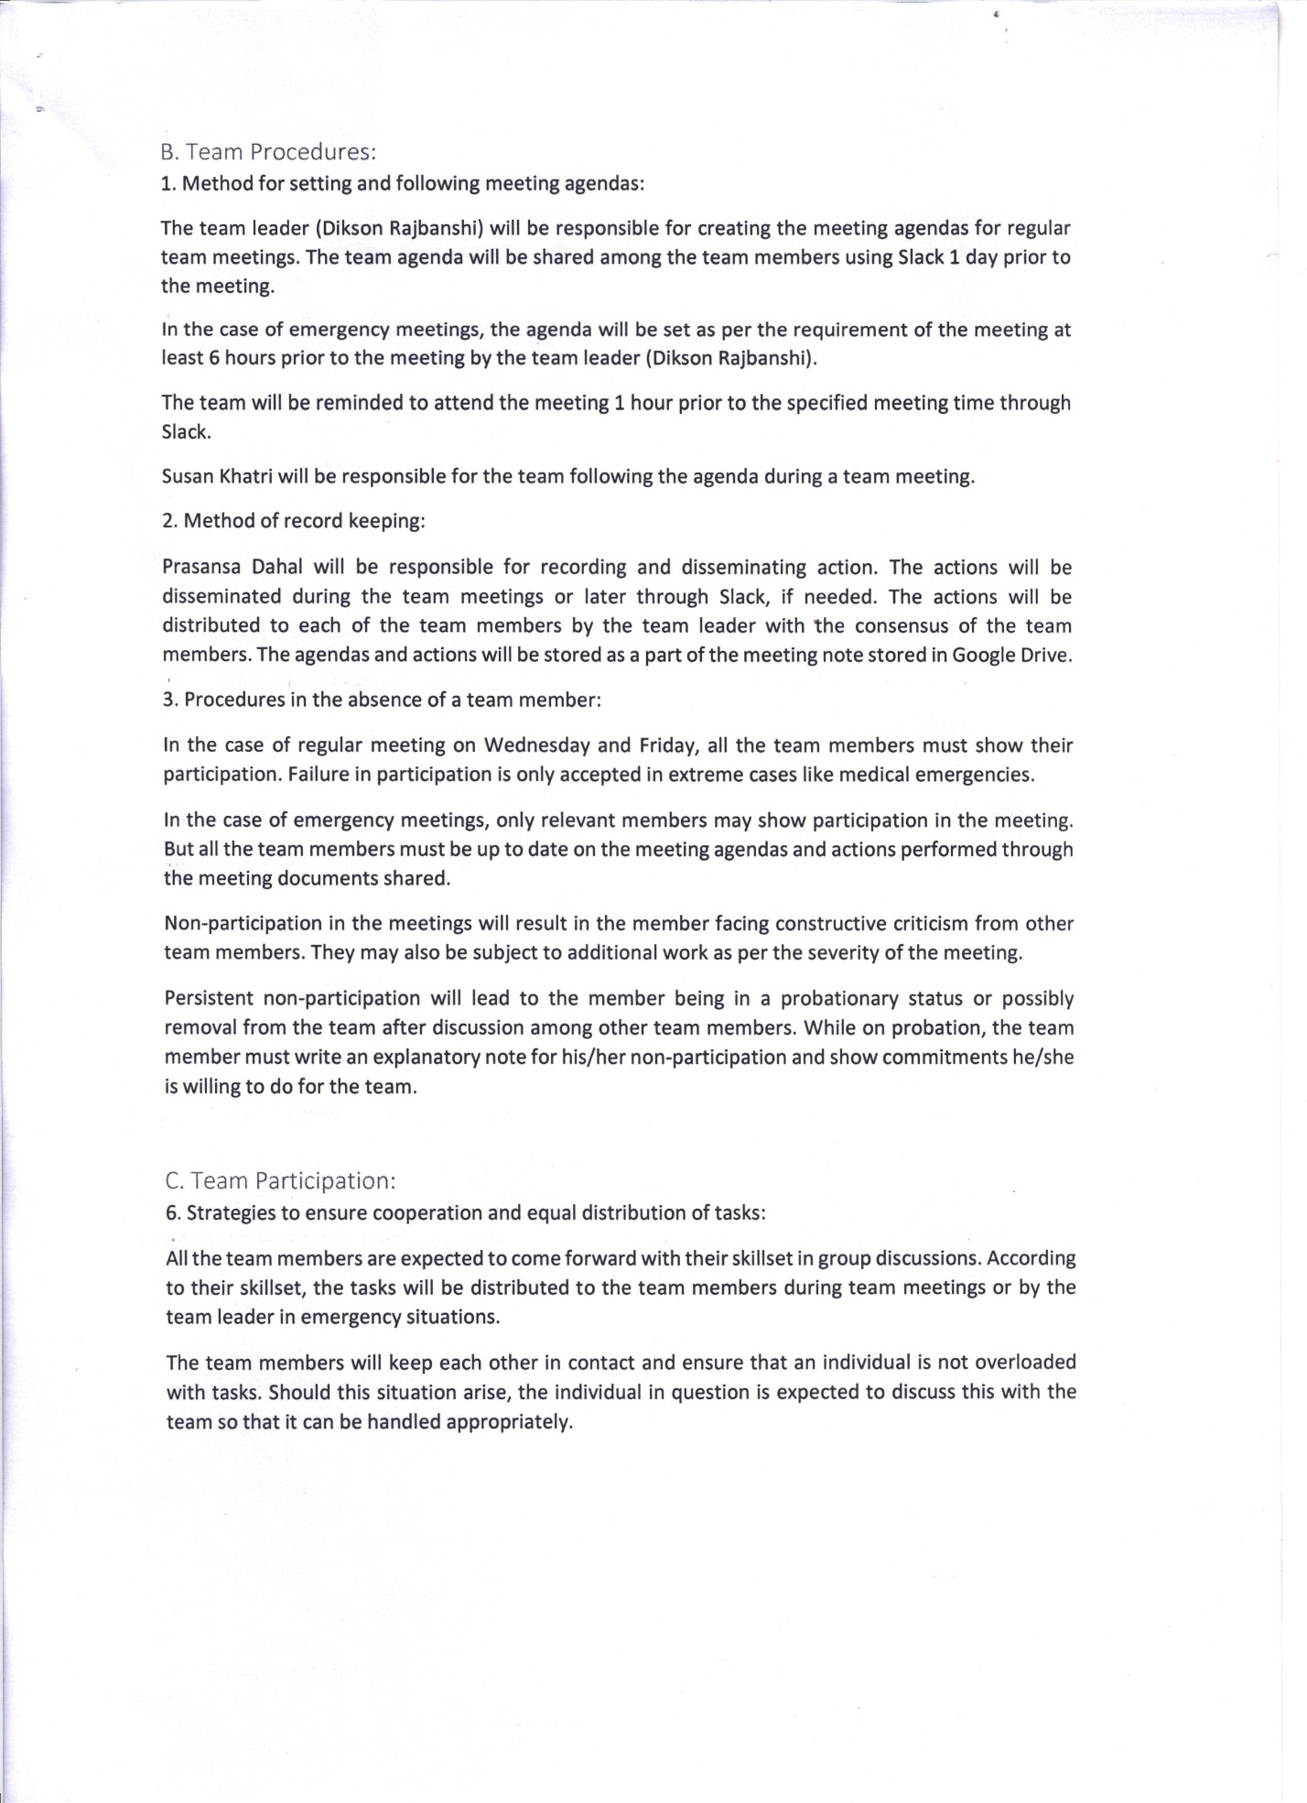

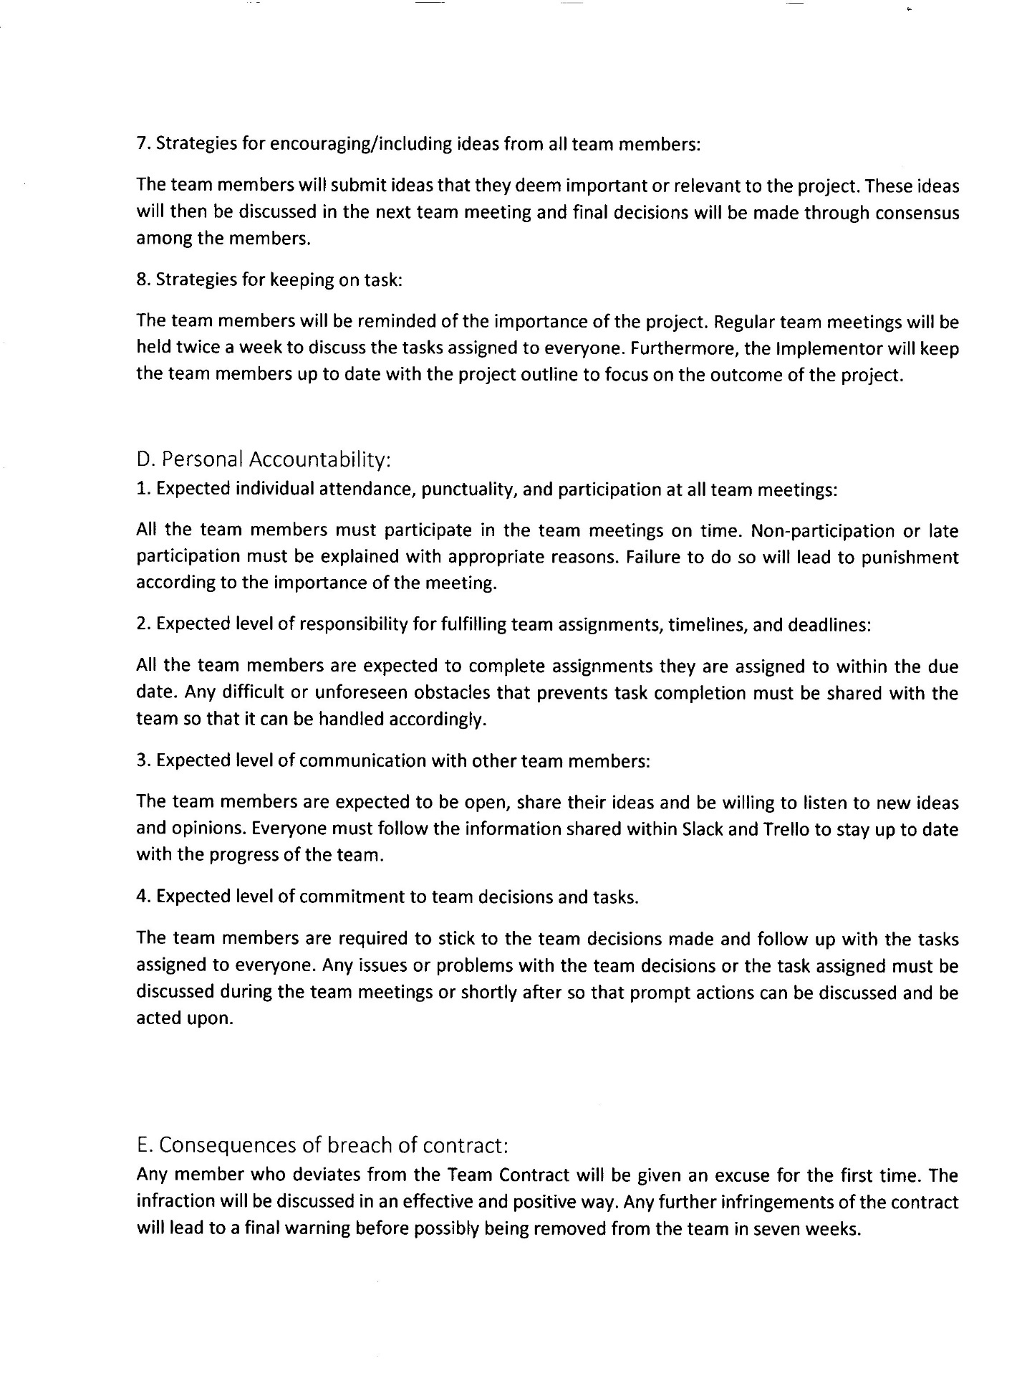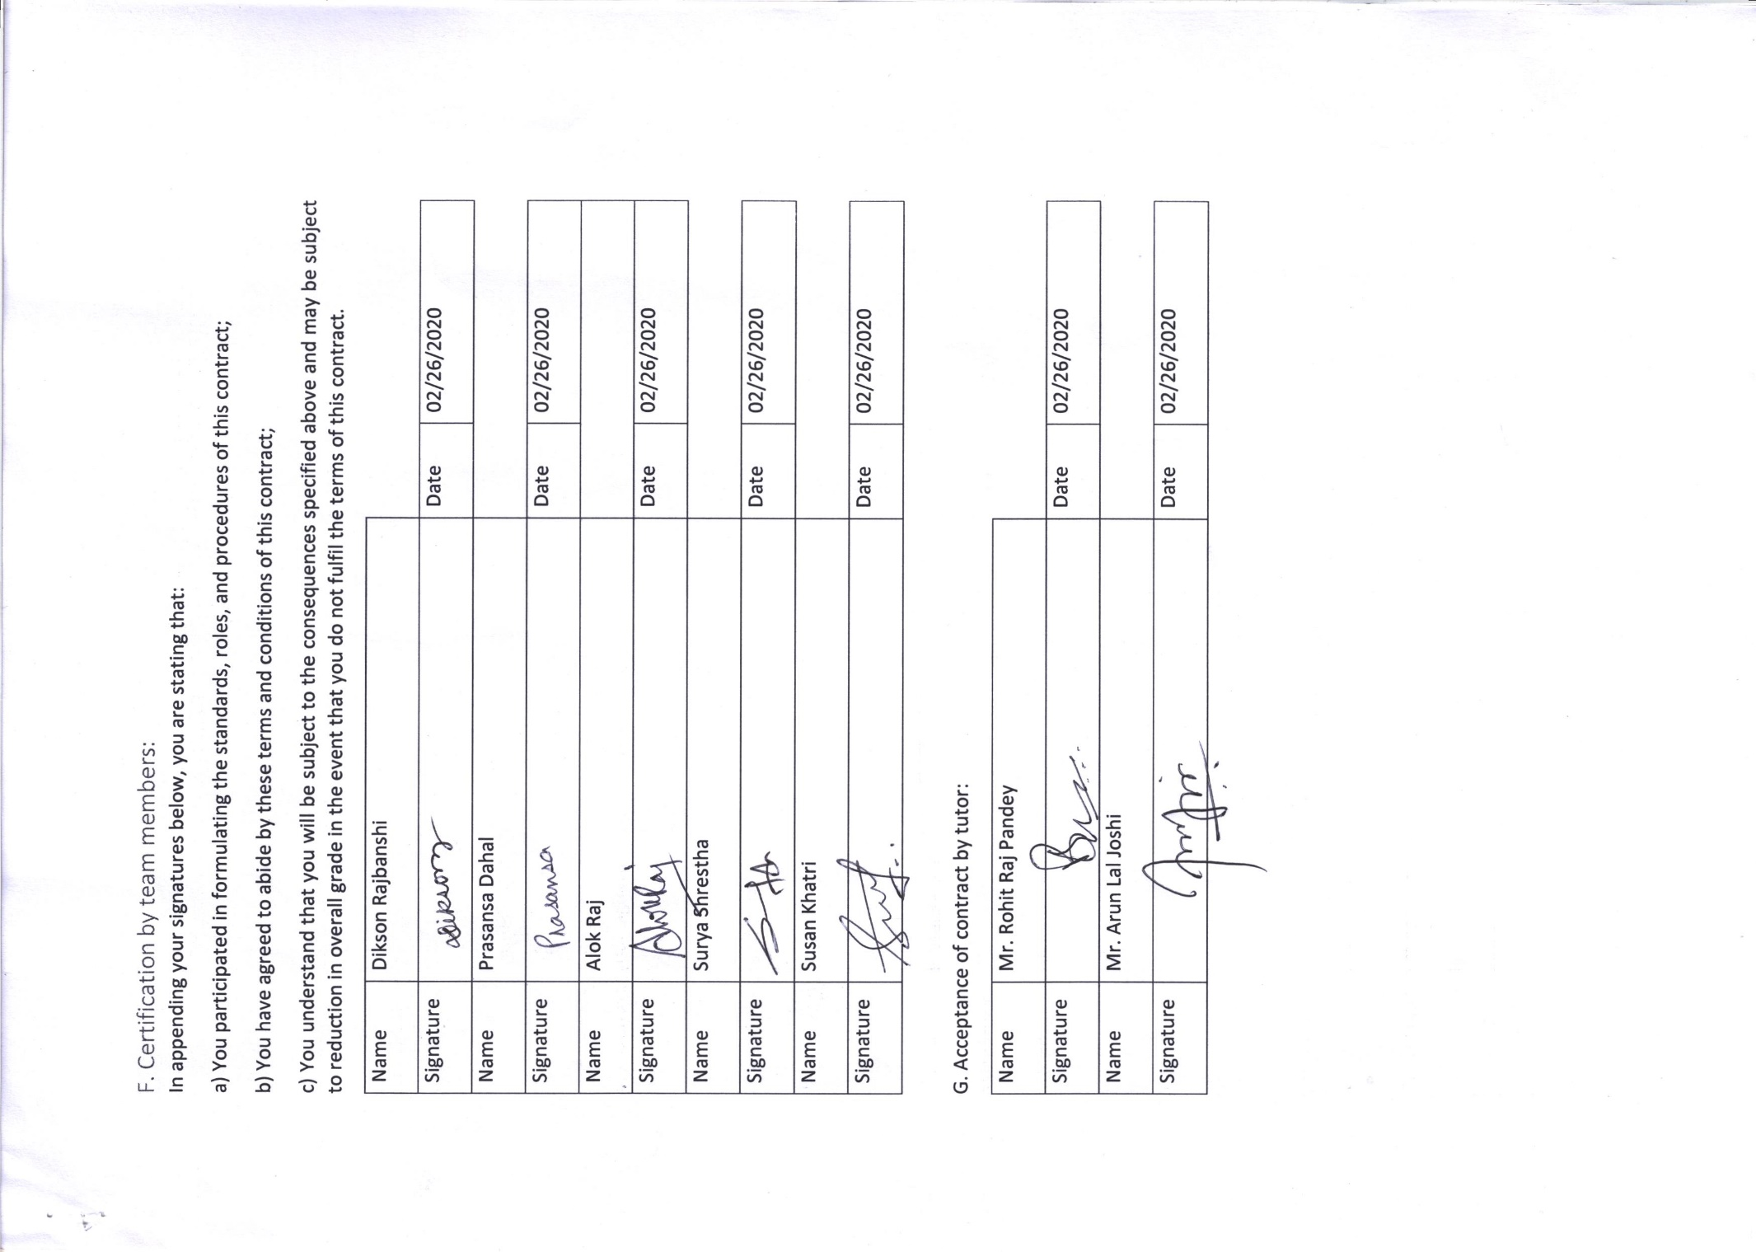

# Project Planning

## Belbin Analysis (Team)

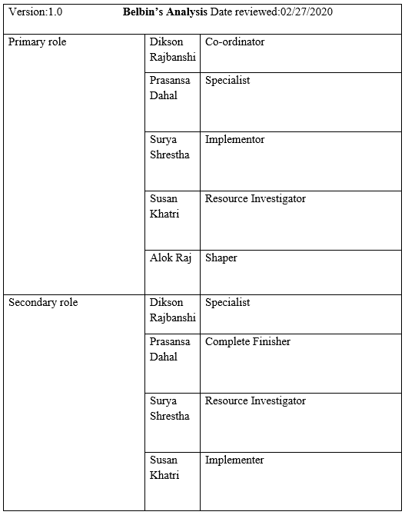

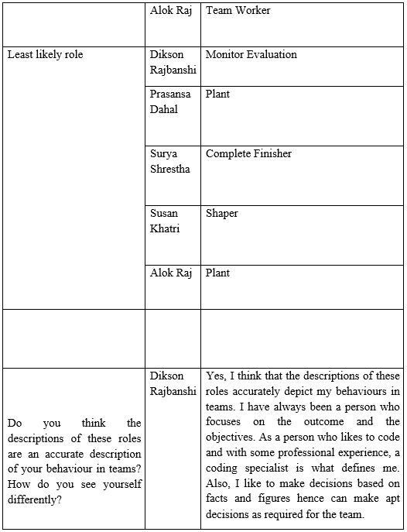

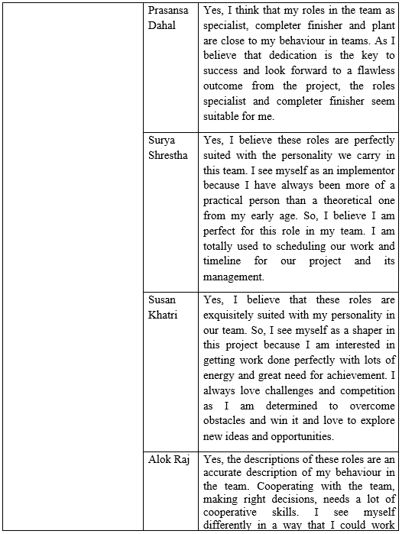

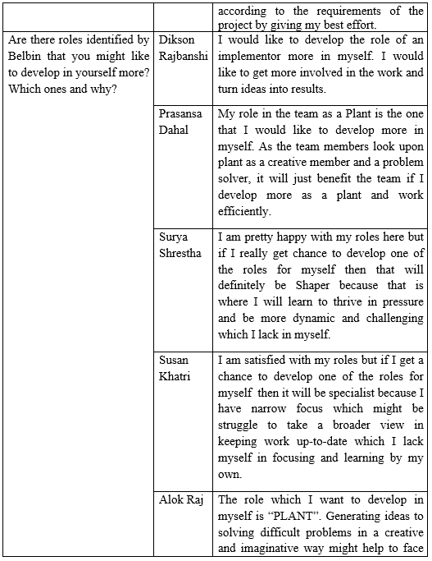

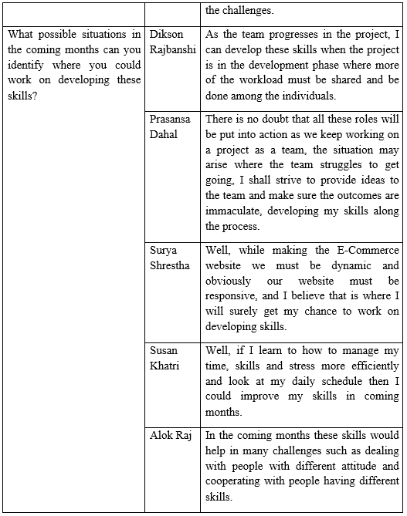

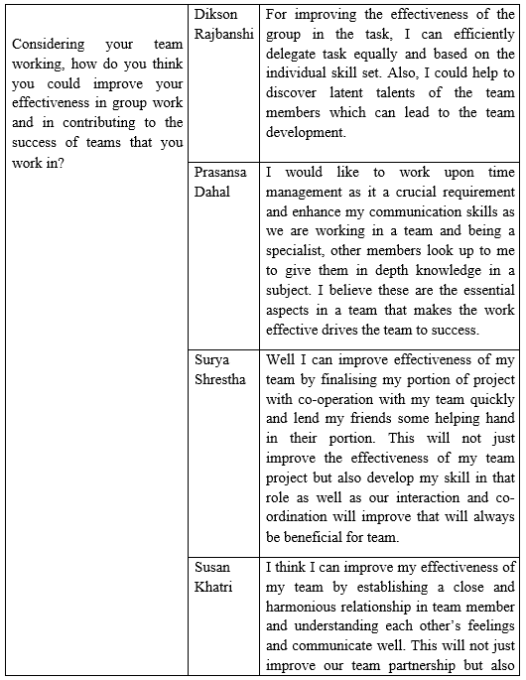

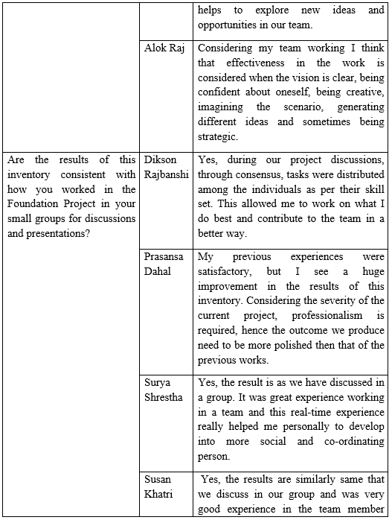

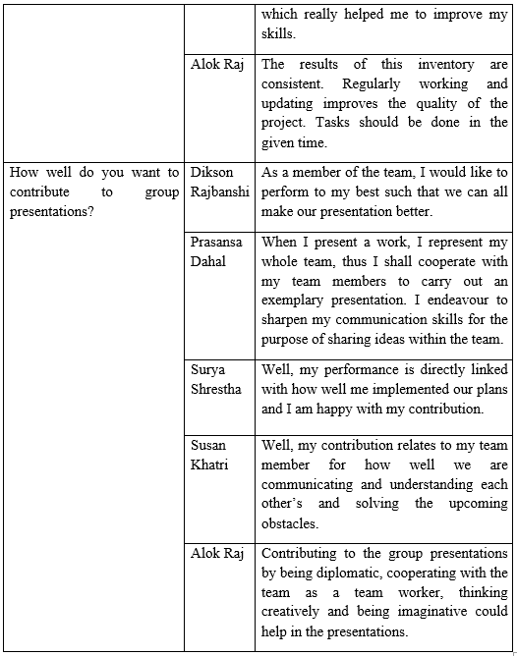

## Belbin Analysis (Individual)

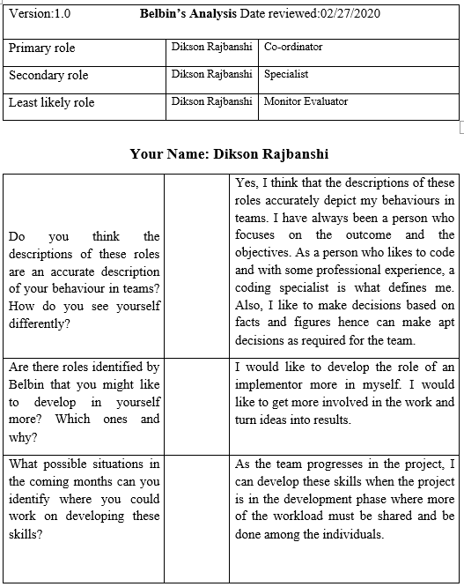

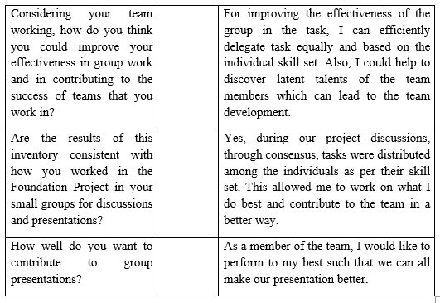

## Skill Audit (Team)



## Skill Audit (Individual)



## Microsoft Project

### Task Sheet

|  |  |  |  |  |  |
| --- | --- | --- | --- | --- | --- |
| Task Name | Duration | Start | Finish | Predecessors | Resource Names |
| **Team A** | **53 days** | **Tue 2/18/20** | **Fri 5/1/20** |  |  |
| **Initial Phase** | **3 days** | **Tue 2/18/20** | **Thu 2/20/20** |  |  |
| Team Formation | 0 days | Tue 2/18/20 | Tue 2/18/20 |  | Rohit Raj Pandey |
| Start Case Study | 1 day | Tue 2/18/20 | Tue 2/18/20 | 3 | Alok Raj, Dikson Rajbanshi, Prasansa Dahal, Surya Shrestha,Susan Khatri |
| **Project Charter** | **2 days** | **Wed 2/19/20** | **Thu 2/20/20** |  |  |
| Finalize Project Name | 0.1 hrs | Wed 2/19/20 | Wed 2/19/20 | 4 | Alok Raj, Dikson Rajbanshi,Prasansa Dahal,Surya Shrestha,Susan Khatri |
| Version Control | 0.1 hrs | Wed 2/19/20 | Wed 2/19/20 | 6 |  |
| Finalize Team Name | 0.1 hrs | Wed 2/19/20 | Wed 2/19/20 | 7 | Alok Raj,Dikson Rajbanshi,Prasansa Dahal,Surya Shrestha,Susan Khatri |
| Roles and Responsibilities Distributuion | 1 hr | Wed 2/19/20 | Wed 2/19/20 | 8 | Dikson Rajbanshi |
| Project Justification Draft | 0.75 days | Thu 2/20/20 | Thu 2/20/20 | 9 | Prasansa Dahal |
| Project Scope | 0.25 days | Thu 2/20/20 | Thu 2/20/20 | 10 | Alok Raj |
| Set Project Goals | 0.25 days | Thu 2/20/20 | Thu 2/20/20 | 11 | Surya Shrestha,Susan Khatri |
| Project Charter Documentation | 0.25 days | Thu 2/20/20 | Thu 2/20/20 | 12 | Dikson Rajbanshi |
| **Planning Phase** | **8 days** | **Fri 2/21/20** | **Tue 3/3/20** |  |  |
| **Create Team Contract** | **3 days** | **Fri 2/21/20** | **Tue 2/25/20** |  |  |
| Contract Description | 0.5 days | Fri 2/21/20 | Fri 2/21/20 | 13 | Dikson Rajbanshi |
| Team Structure | 0.5 days | Fri 2/21/20 | Fri 2/21/20 | 16SS | Alok Raj,Surya Shrestha |
| Team Procedures | 0.5 days | Mon 2/24/20 | Mon 2/24/20 | 17 | Prasansa Dahal,Susan Khatri |
| Team Participation | 0.5 days | Mon 2/24/20 | Mon 2/24/20 | 18 | Dikson Rajbanshi,Susan Khatri |
| Personal Accountability | 0.25 days | Tue 2/25/20 | Tue 2/25/20 | 19 | Alok Raj,Dikson Rajbanshi,Prasansa Dahal,Surya Shrestha,Susan Khatri |
| Contract Breach Consequences | 0.25 days | Tue 2/25/20 | Tue 2/25/20 | 20 | Alok Raj,Surya Shrestha |
| Certification by Team Members | 0.25 days | Tue 2/25/20 | Tue 2/25/20 | 21 | Alok Raj,Dikson Rajbanshi,Prasansa Dahal,Surya Shrestha,Susan Khatri |
| Finalize Contract | 0.25 days | Tue 2/25/20 | Tue 2/25/20 | 22 | Alok Raj,Dikson Rajbanshi,Prasansa Dahal,Surya Shrestha,Susan Khatri |
| **Belbin Analysis** | **2 days** | **Mon 2/24/20** | **Tue 2/25/20** |  |  |
| Individual Belbin | 1 day | Mon 2/24/20 | Mon 2/24/20 |  | Alok Raj,Dikson Rajbanshi,Prasansa Dahal,Surya Shrestha,Susan Khatri |
| Team Belbin | 0.5 days | Tue 2/25/20 | Tue 2/25/20 | 25 | Dikson Rajbanshi |
| Documentation for Submission | 0.5 days | Tue 2/25/20 | Tue 2/25/20 | 26 | Dikson Rajbanshi |
| **Skills Audit** | **2 days** | **Wed 2/26/20** | **Thu 2/27/20** |  |  |
| Individual Skills Audit | 1 day | Wed 2/26/20 | Wed 2/26/20 | 27 | Alok Raj,Dikson Rajbanshi,Prasansa Dahal,Surya Shrestha,Susan Khatri |
| Team Skills Audit | 0.5 days | Thu 2/27/20 | Thu 2/27/20 | 29 | Susan Khatri |
| Documentation for Submission | 0.5 days | Thu 2/27/20 | Thu 2/27/20 | 30 | Dikson Rajbanshi |
| **Website Outline** | **1 day** | **Fri 2/28/20** | **Fri 2/28/20** |  |  |
| Create Website Outline | 0.5 days | Fri 2/28/20 | Fri 2/28/20 | 31 | Alok Raj,Dikson Rajbanshi,Prasansa Dahal,Surya Shrestha,Susan Khatri |
| Finalize Website Outline | 0.5 days | Fri 2/28/20 | Fri 2/28/20 | 33SS | Alok Raj,Dikson Rajbanshi,Surya Shrestha,Susan Khatri,Prasansa Dahal |
| **Organize MS Project** | **2 days** | **Mon 3/2/20** | **Tue 3/3/20** | **32** |  |
| Training | 0.5 days | Mon 3/2/20 | Mon 3/2/20 |  | Prasansa Dahal |
| Set Tasks | 1 day | Mon 3/2/20 | Mon 3/2/20 | 36SS | Prasansa Dahal,Dikson Rajbanshi |
| Create Team Calendar | 0.1 hrs | Tue 3/3/20 | Tue 3/3/20 | 37 | Prasansa Dahal |
| Change Working Time | 0.1 hrs | Tue 3/3/20 | Tue 3/3/20 | 38SS | Prasansa Dahal |
| Create Timeline | 0.1 hrs | Tue 3/3/20 | Tue 3/3/20 | 39SS | Prasansa Dahal |
| Edit Work Breakdown Structure | 0.1 hrs | Tue 3/3/20 | Tue 3/3/20 | 40SS | Prasansa Dahal,Dikson Rajbanshi |
| Manage Gantt Chart | 0.1 hrs | Tue 3/3/20 | Tue 3/3/20 | 41SS | Prasansa Dahal |
| Set Resources | 0.1 hrs | Tue 3/3/20 | Tue 3/3/20 | 42SS | Prasansa Dahal |
| **Execution Phase** | **27 days** | **Wed 3/4/20** | **Fri 4/10/20** |  |  |
| **Requirement Catalogue** | **1 day** | **Wed 3/4/20** | **Wed 3/4/20** |  |  |
| Functional Requirement | 0.5 days | Wed 3/4/20 | Wed 3/4/20 | 43 | Alok Raj,Prasansa Dahal |
| Non-functional Requirement | 0.5 days | Wed 3/4/20 | Wed 3/4/20 | 46SS | Alok Raj,Prasansa Dahal |
| **Entity Relationship Diagram** | **2 days** | **Thu 3/5/20** | **Fri 3/6/20** |  |  |
| Create Entity Realtionship Diagram | 1 day | Thu 3/5/20 | Thu 3/5/20 | **45** | Dikson Rajbanshi,Susan Khatri |
| Create Composite ERD | 0.5 days | Fri 3/6/20 | Fri 3/6/20 | 49 | Alok Raj |
| Create Extended Entity Relationship Didagram | 0.25 days | Fri 3/6/20 | Fri 3/6/20 | 50SS | Surya Shrestha,Dikson Rajbanshi |
| Create Logical Design | 0.25 days | Fri 3/6/20 | Fri 3/6/20 | 51SS | Prasansa Dahal |
| **Use Case Diagram** | **2 days** | **Fri 3/6/20** | **Tue 3/10/20** |  |  |
| Overview | 0.25 days | Mon 3/9/20 | Mon 3/9/20 | 52 | Dikson Rajbanshi |
| Admin Access | 0.5 days | Mon 3/9/20 | Mon 3/9/20 | 54SS | Alok Raj,Prasansa Dahal |
| Trader Access | 0.5 days | Mon 3/9/20 | Mon 3/9/20 | 55SS | Surya Shrestha |
| Customer Access | 0.5 days | Tue 3/10/20 | Tue 3/10/20 | 56 | Susan Khatri |
| Finalize Use Case Diagram | 0.25 days | Tue 3/10/20 | Tue 3/10/20 | 57 | Alok Raj,Dikson Rajbanshi,Prasansa Dahal,Surya Shrestha,Susan Khatri |
| **Logo Design** | **1 day** | **Wed 3/11/20** | **Wed 3/11/20** |  |  |
| Research Designs | 0.5 days | Wed 3/11/20 | Wed 3/11/20 | 58 | Susan Khatri |
| Create Sample Logo | 0.5 days | Wed 3/11/20 | Wed 3/11/20 | 60SS | Dikson Rajbanshi |
| **Wireframe Design** | **3 days** | **Thu 3/12/20** | **Mon 3/16/20** |  |  |
| Create Wireframe | 3 days | Thu 3/12/20 | Mon 3/16/20 | 61 | Alok Raj |
| Frontend Training | 1 day | Thu 3/12/20 | Thu 3/12/20 | 62SS | Alok Raj,Dikson Rajbanshi,Prasansa Dahal,Surya Shrestha,Susan Khatri |
| Website Coding Frontend | 4 days | Fri 3/13/20 | Fri 3/13/20 | 64 | Surya Shrestha,Susan Khatri |
| **Work In Progress** | **4 days** | Thu 3/19/20 | **Tue 3/24/20** | **62** |  |
| Documentation | 2 days | Thu 3/19/20 | Fri 3/20/20 | 65 | Dikson Rajbanshi |
| Create Presentation | 1 day | Mon 3/23/20 | Mon 3/23/20 | 67 | Surya Shrestha |
| Presentation Submission | 1 day | Tue 3/24/20 | Tue 3/24/20 | 68 | Alok Raj,Dikson Rajbanshi,Prasansa Dahal,Surya Shrestha,Susan Khatri |
| Finalize Website Frontend | 5 days | Wed 3/25/20 | Tue 3/31/20 | 65 | Dikson Rajbanshi,Surya Shrestha,Susan Khatri |
| **Website Backend** | **8 days** | **Wed 4/1/20** | **Fri 4/10/20** |  |  |
| Backend Training | 2 days | Wed 4/1/20 | Thu 4/2/20 | 70 | Alok Raj,Dikson Rajbanshi,Prasansa Dahal,Surya Shrestha,Susan Khatri |
| Initiate Coding | 7 days | Wed 4/1/20 | Thu 4/9/20 | 72SS | Alok Raj,Dikson Rajbanshi,Surya Shrestha |
| Finalize Coding | 1 day | Fri 4/10/20 | Fri 4/10/20 | 73 | Prasansa Dahal,Susan Khatri |
| **Monitoring and Controlling Phase** | **12 days** | **Mon 4/13/20** | **Tue 4/28/20** |  |  |
| **Testing and Evaluation** | **6 days** | **Mon 4/13/20** | **Mon 4/20/20** | **70** |  |
| Test Website | 1 day | Mon 4/13/20 | Mon 4/13/20 |  | Alok Raj,Dikson Rajbanshi,Prasansa Dahal,Surya Shrestha,Susan Khatri |
| Edit Website | 3 days | Mon 4/13/20 | Wed 4/15/20 | 77SS | Dikson Rajbanshi,Prasansa Dahal |
| Finalize Website | 2 days | Mon 4/13/20 | Tue 4/14/20 | 78SS | Alok Raj,Surya Shrestha,Susan Khatri |
| **Set Up User Installation Manual** | **1 day** | **Tue 4/28/20** | **Tue 4/28/20** |  |  |
| Register and Login | 0.25 days | Tue 4/28/20 | Tue 4/28/20 | 79 | Prasansa Dahal |
| Admin Manual | 0.25 days | Tue 4/28/20 | Tue 4/28/20 | 81SS | Alok Raj |
| Trader Manual | 0.25 days | Tue 4/28/20 | Tue 4/28/20 | 82SS | Dikson Rajbanshi |
| Customer Manual | 0.25 days | Tue 4/28/20 | Tue 4/28/20 | 83SS | Surya Shrestha |
| **Closing Phase** | **3 days** | **Wed 4/29/20** | **Fri 5/1/20** |  |  |
| Set Up User Installation Manual | 1 day | Wed 4/29/20 | Wed 4/29/20 | 84 | Susan Khatri |
| Create Final Presentation | 2 days | Wed 4/29/20 | Thu 4/30/20 | 86SS | Alok Raj,Prasansa Dahal |
| Final Team Documentation | 1 day | Wed 4/29/20 | Wed 4/29/20 | 86SS | Dikson Rajbanshi,Susan Khatri |
| Final Team Portfolio for Submission | 1 day | Wed 4/29/20 | Wed 4/29/20 | 86SS | Alok Raj,Dikson Rajbanshi,Prasansa Dahal,Susan Khatri,Surya Shrestha |
| Final Presentation for Submission | 1 day | Fri 5/1/20 | Fri 5/1/20 | 87 | Alok Raj,Dikson Rajbanshi,Prasansa Dahal,Surya Shrestha,Susan Khatri |

### Gantt Chart

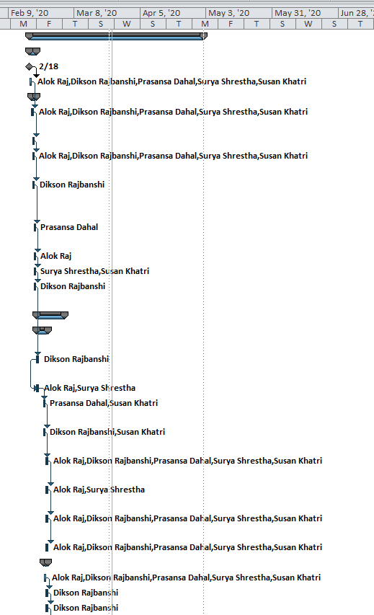

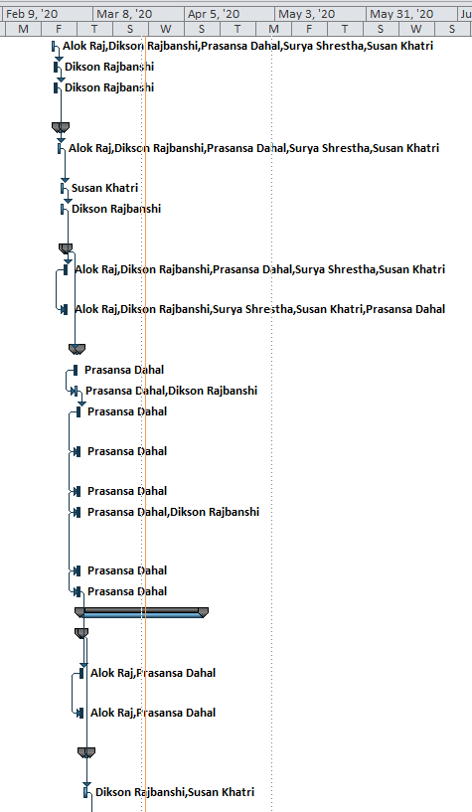

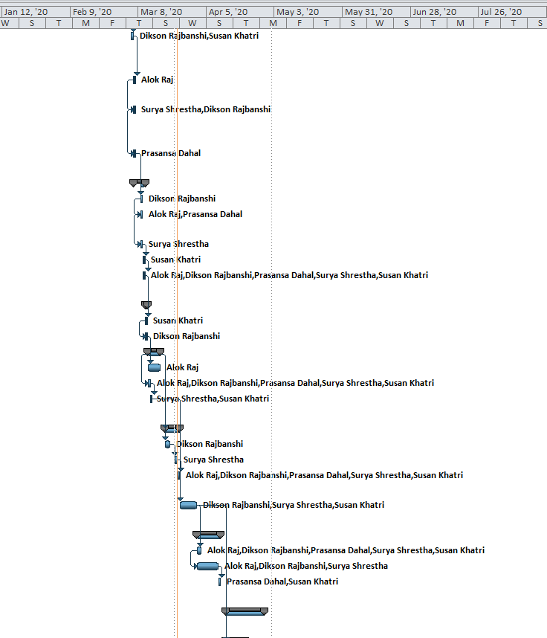

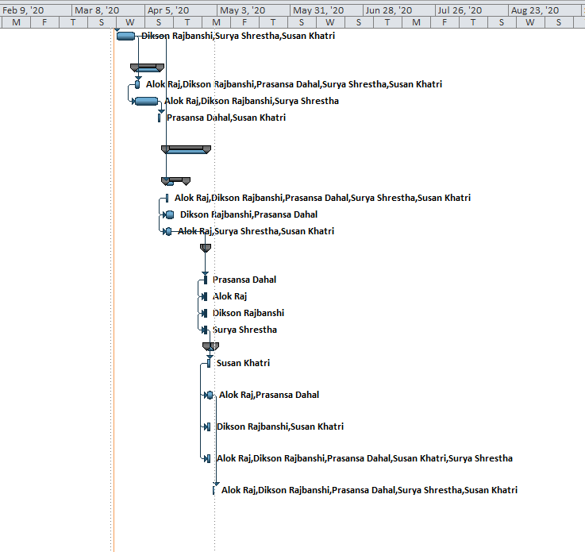

### Calendar

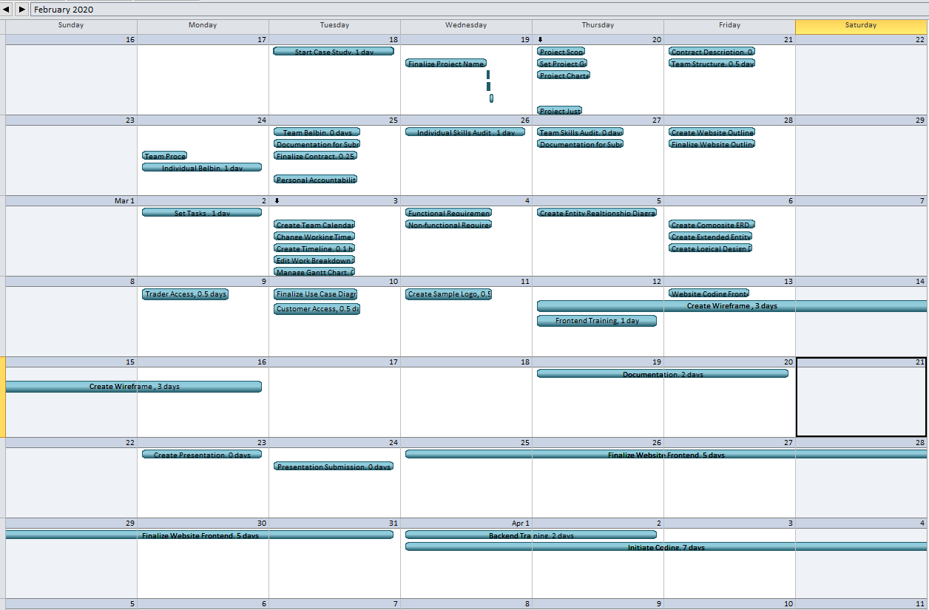

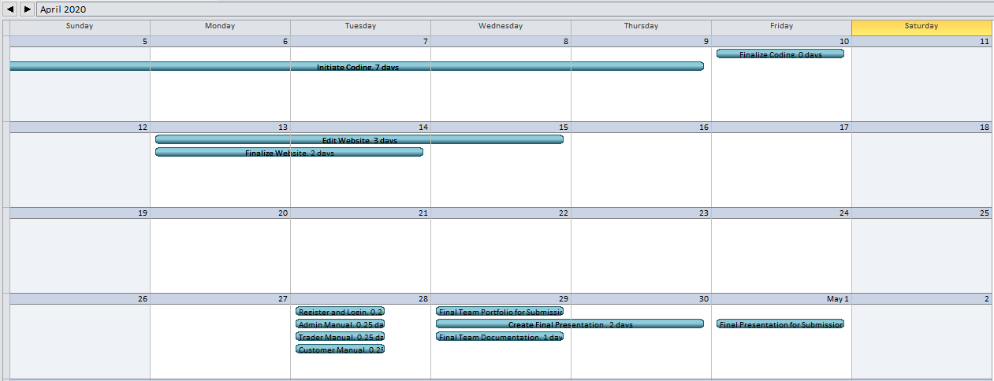

### Network Diagram

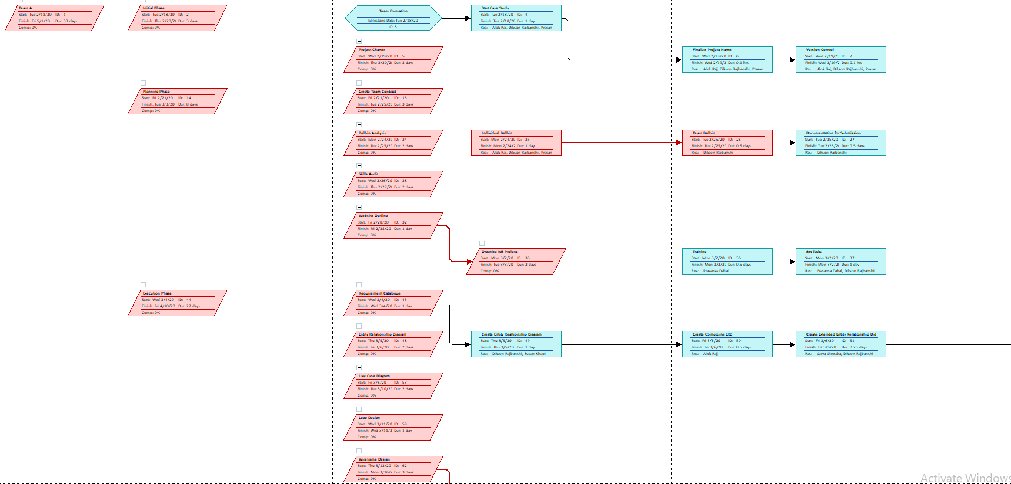

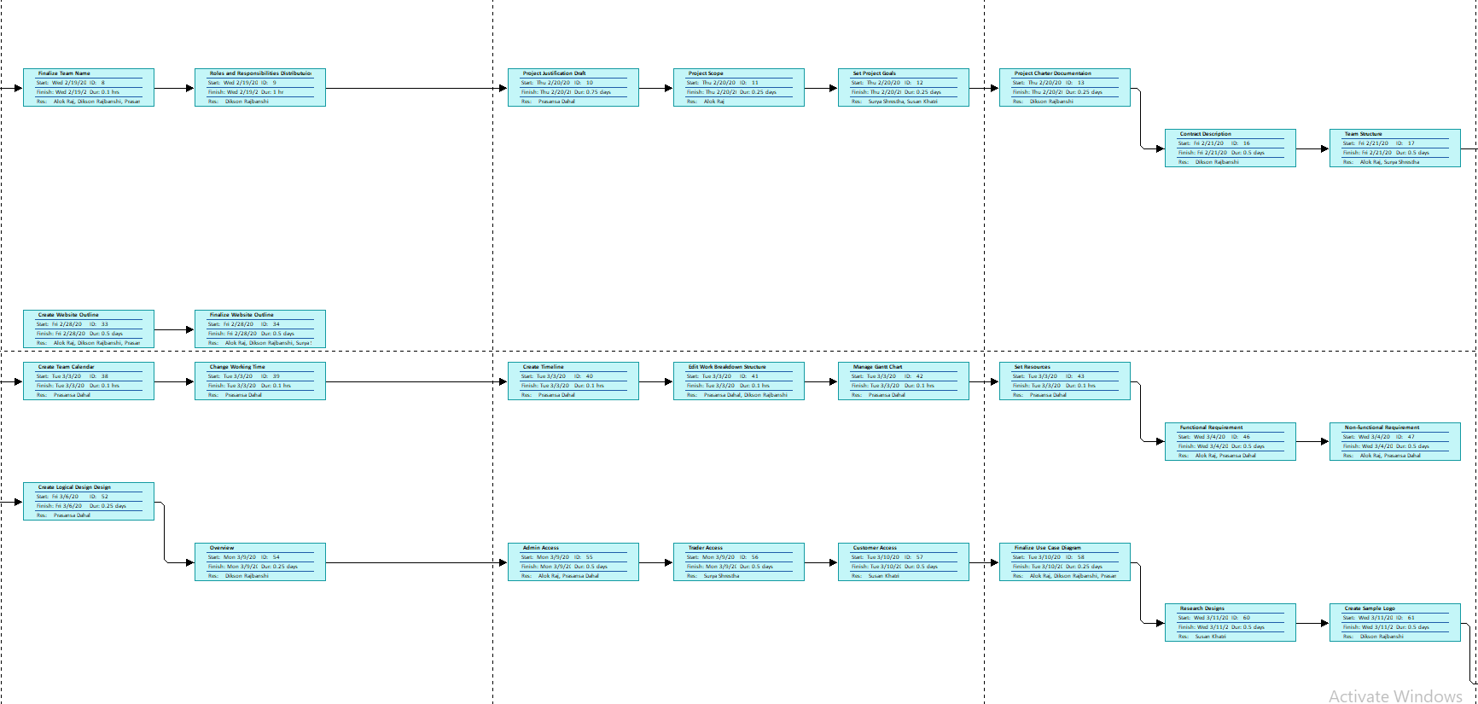

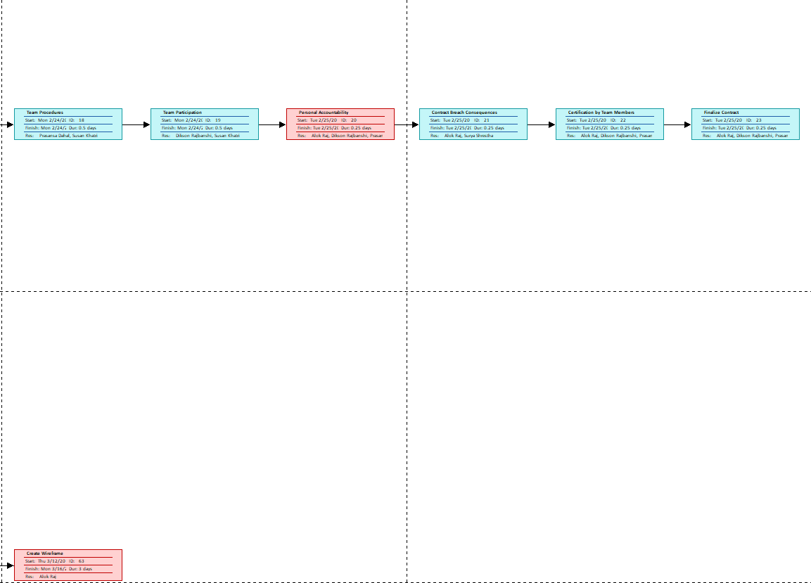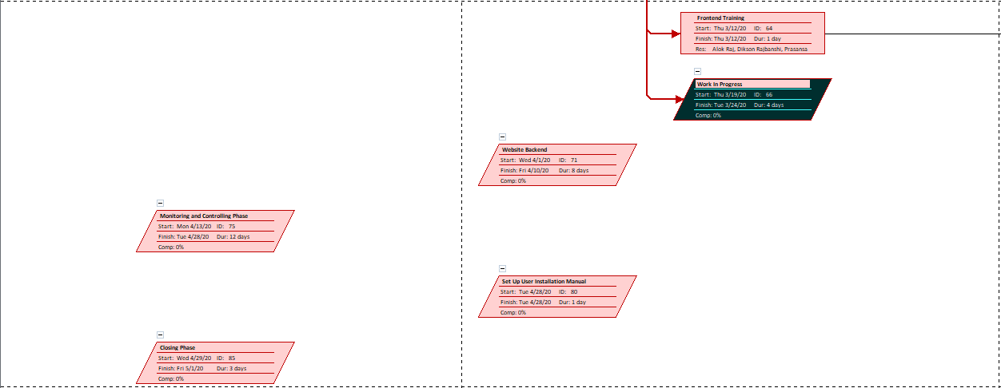

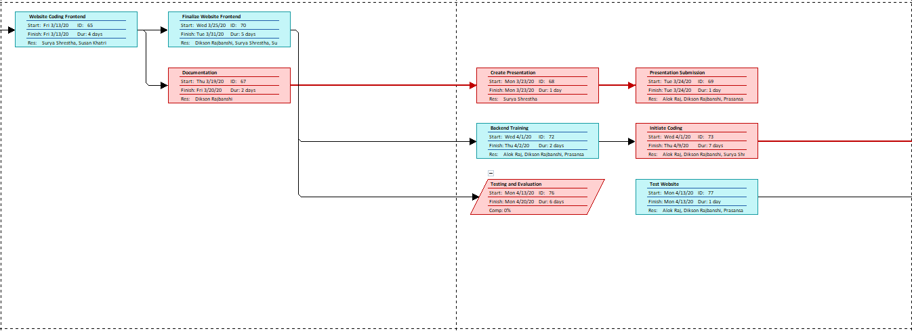

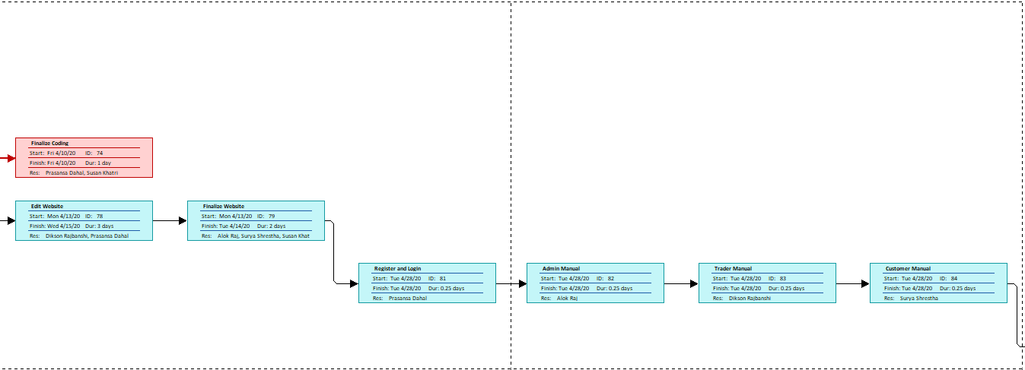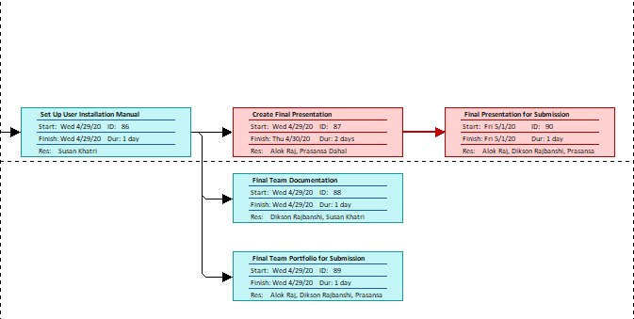

### Resource Sheet

|  |  |  |  |  |  |  |  |  |  |  |
| --- | --- | --- | --- | --- | --- | --- | --- | --- | --- | --- |
| Resource Name | Type | Material Label | Initials | Group | Max. Units | Std. Rate | Ovt. Rate | Cost/Use | Accrue At | Base Calendar |
| Writer | Work |  | W |  | 100% | $0.00/hr | $0.00/hr | $0.00 | Prorated | Standard |
| Editor | Work |  | E |  | 100% | $0.00/hr | $0.00/hr | $0.00 | Prorated | Standard |
| Arun Joshi | Work |  | A |  | 100% | $0.00/hr | $0.00/hr | $0.00 | Prorated | Team A |
| Rohit Raj Pandey | Work |  | R |  | 100% | $0.00/hr | $0.00/hr | $0.00 | Prorated | Standard |
| Dikson Rajbanshi | Work |  | D |  | 100% | $0.00/hr | $0.00/hr | $0.00 | Prorated | Standard |
| Prasansa Dahal | Work |  | P |  | 100% | $0.00/hr | $0.00/hr | $0.00 | Prorated | Standard |
| Surya Shrestha | Work |  | S |  | 100% | $0.00/hr | $0.00/hr | $0.00 | Prorated | Standard |
| Susan Khatri | Work |  | S |  | 100% | $0.00/hr | $0.00/hr | $0.00 | Prorated | Standard |
| Alok Raj | Work |  | A |  | 100% | $0.00/hr | $0.00/hr | $0.00 | Prorated | Standard |
| Glossy Paper | Material | Xerox | G |  |  | $0.00 |  | $0.00 | Prorated |  |
| Printer | Work |  | P |  | 100% | $0.00/hr | $0.00/hr | $0.00 | Prorated | Standard |
| Pen | Material | Cello | P |  |  | $0.00 |  | $0.00 | Prorated |  |
| Laptop | Work |  | L |  | 100% | $0.00/hr | $0.00/hr | $0.00 | Prorated | Standard |
| QSEE | Material |  | Q |  |  | $0.00 |  | $0.00 | Prorated |  |
| MS Project Professional | Material | Microsoft | M |  |  | $0.00 |  | $0.00 | Prorated |  |
| MS Word | Material | Microsoft | M |  |  | $0.00 |  | $0.00 | Prorated |  |
| Oracle Database | Material | Oracle | O |  |  | $0.00 |  | $0.00 | Prorated |  |

Timeline



## Team Meetings

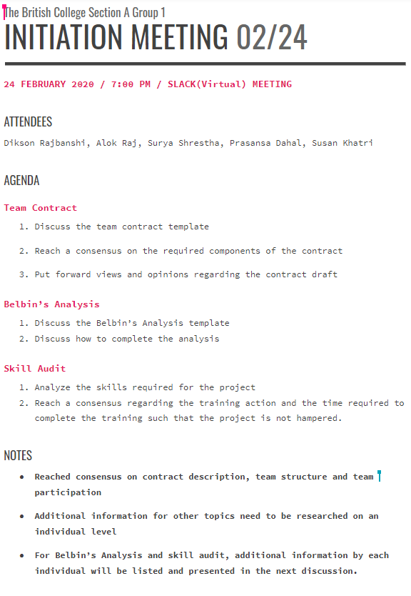

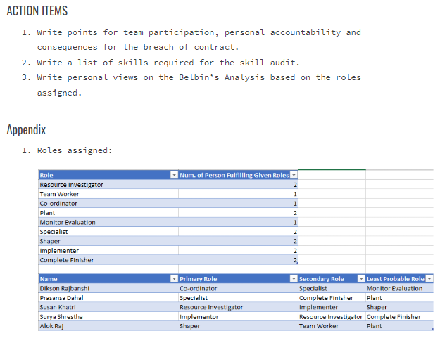

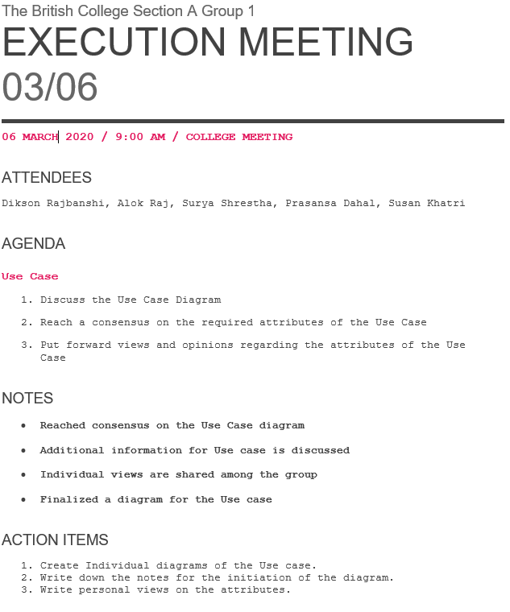

## Communication and Collaboration Tools Used

### Trello

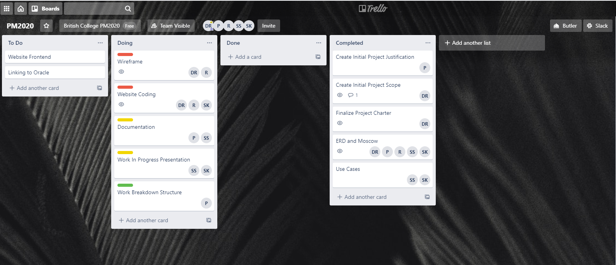

### Slack

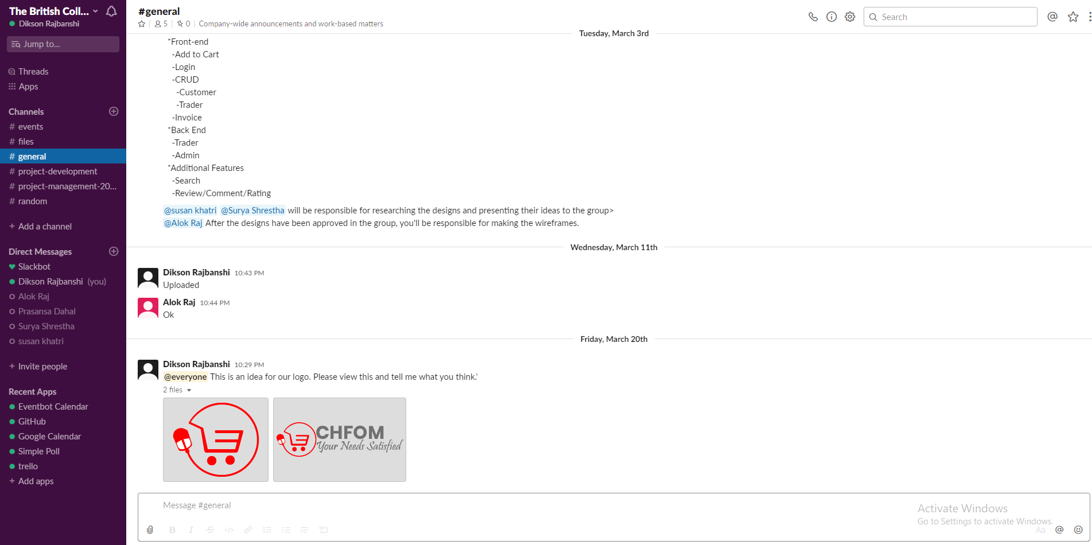

### GitHub

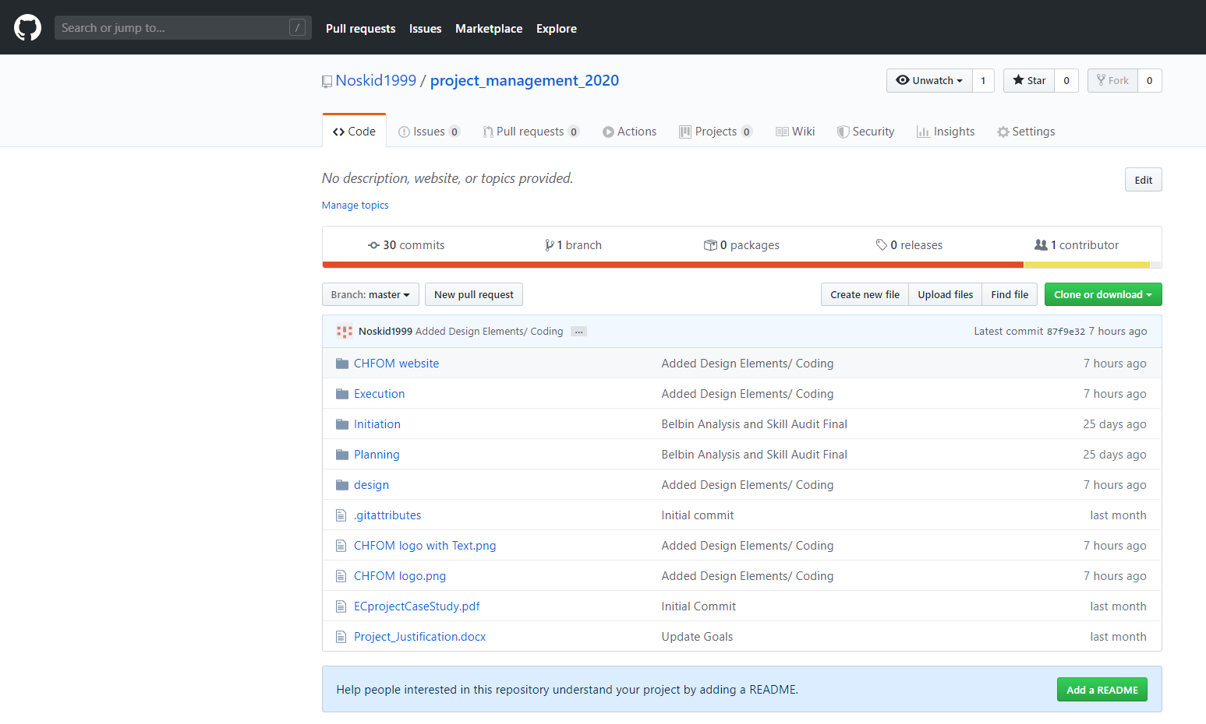

# Project Execution

## Requirements

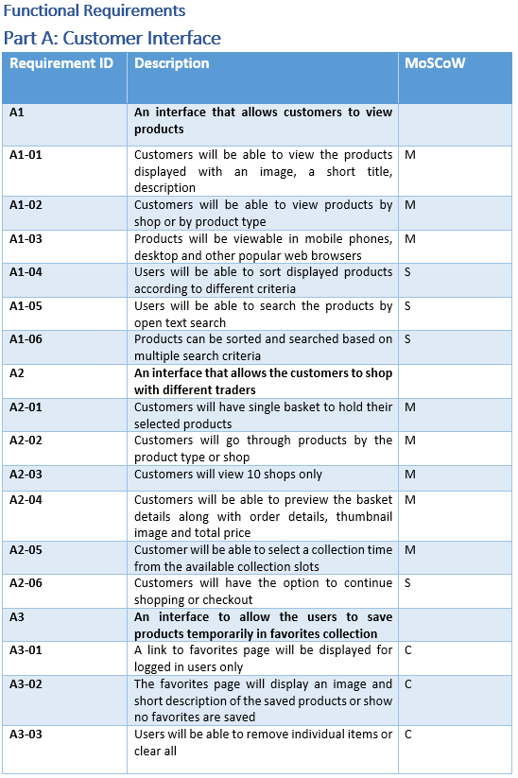

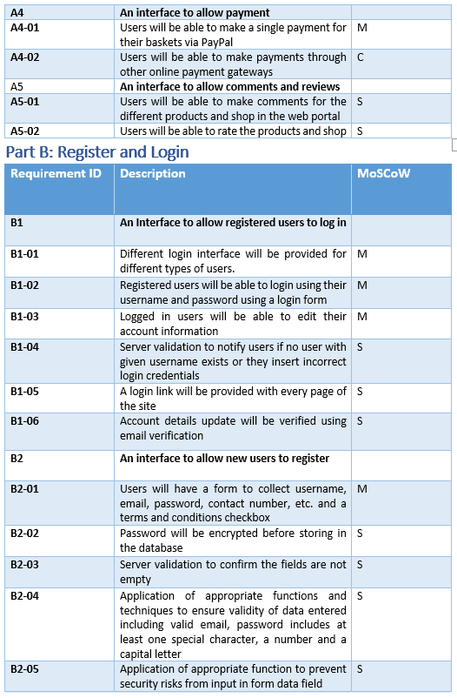

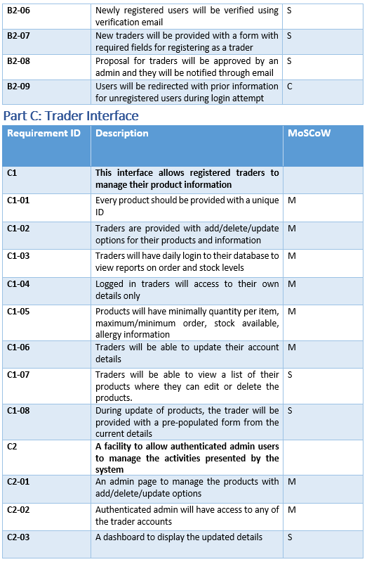

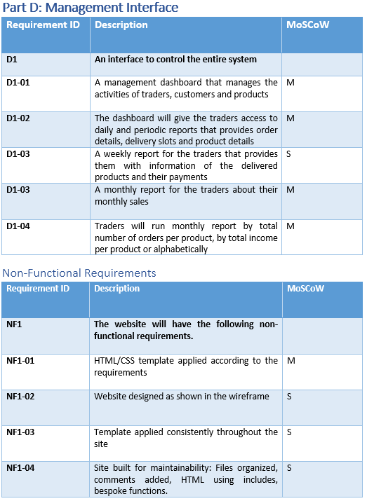

## Entity Relationship Diagram (ERD)

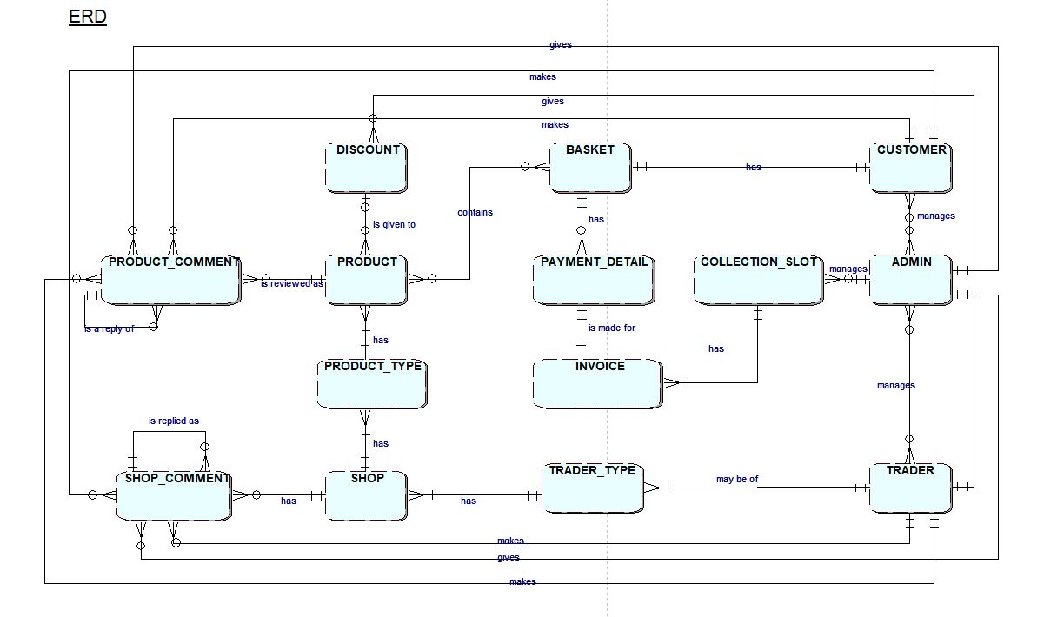

## Extended Entity Relationship Diagram (EERD)

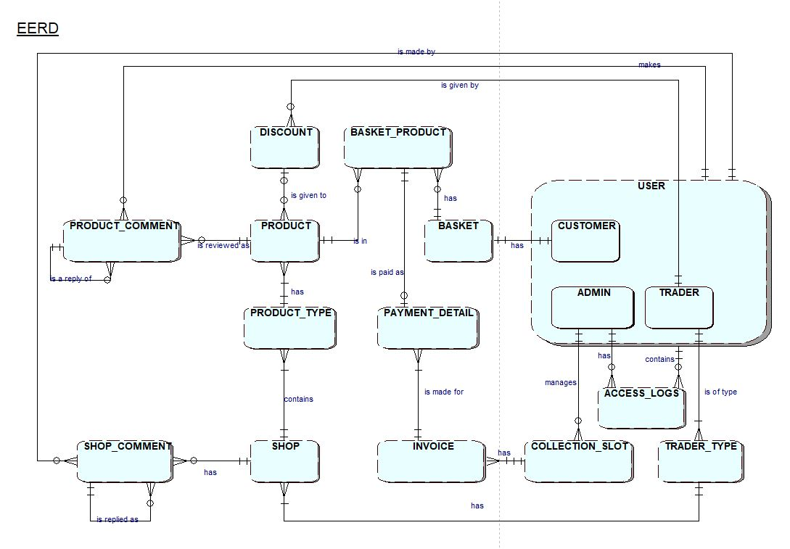

## Composite ERD

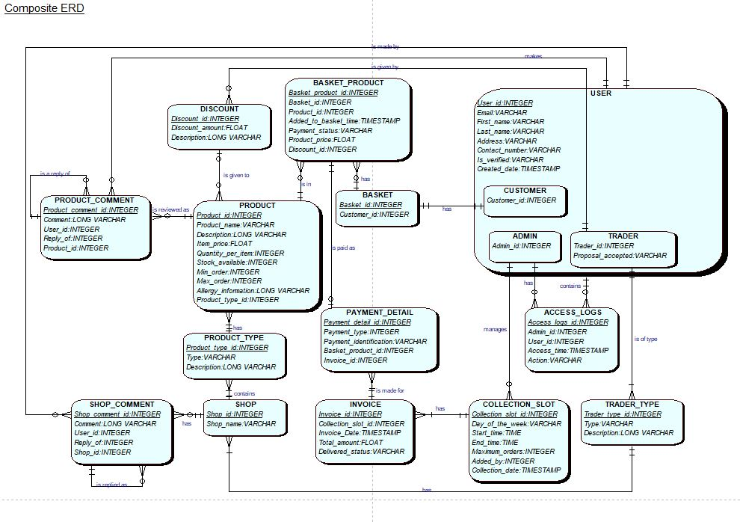

## Logical Design

* USER (User_id, Email, First_name, Last_name, Address, Contact_number, Is_verified, Created_date)
* CUSTOMER (Customer_id, *User_id*)
* ADMIN (Admin_id, *User_id)*
* TRADER (Trader_id, Proposal_accepted, *User_id)*
* PRODUCT (Product_id, Product_name, Description, Item_price, Quantity_per_item, Stock_available, Min_order, Max_order, Allergy_information, *Product_type_id, Discount_id*)
* BASKET (Basket_id, *Customer_id*)
* BASKET_PRODUCT (Basket_product_id, *Basket_id, Product_id*, Added_to_basket_time, Payment_status, Product_price, *Discount_id*)
* PAYMENT_DETAIL (Payment_detail_id, Payment_type, Payment_identification, *Basket_product_id, Invoice_id*)
* INVOICE (Invoice_id, *Collection_slot_id,* Invoice_date, Total_amount, Delivered_status)
* COLLECTION_SLOT (Collection_slot_id, Day_of_the_week, Start_time, End_time, Maximum_orders, *Added_by*, Collection_date)
* ACCESS_LOGS (Access_logs_id, *Admin_id, User_id,* Access_time, Action)
* TRADER_TYPE (Trader_type_id, Type, Description)
* SHOP (Shop_id, Shop_name)
* PRODUCT_TYPE (Product_type_id, Type, Description, *Shop_id*)
* DISCOUNT (Discount_id, Discount_amount, Description)
* SHOP_COMMENT (Shop_comment_id, Comment, *User_id, Reply_of, Product_id*)
* PRODUCT_COMMENT (Product_comment_id, Comment, *User_id, Reply_of, Shop_id*)

## Use Case

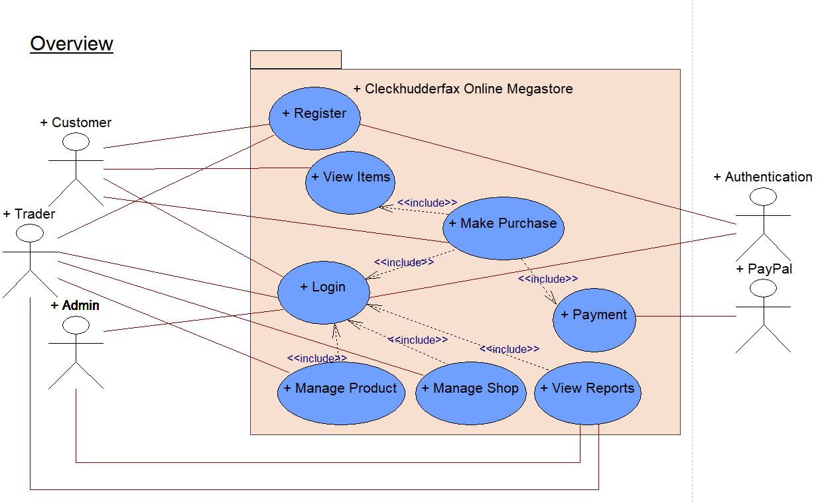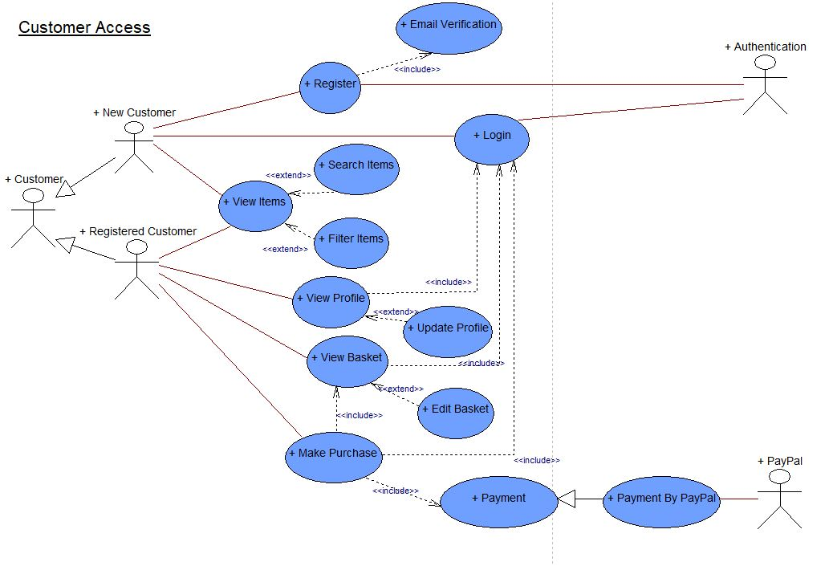

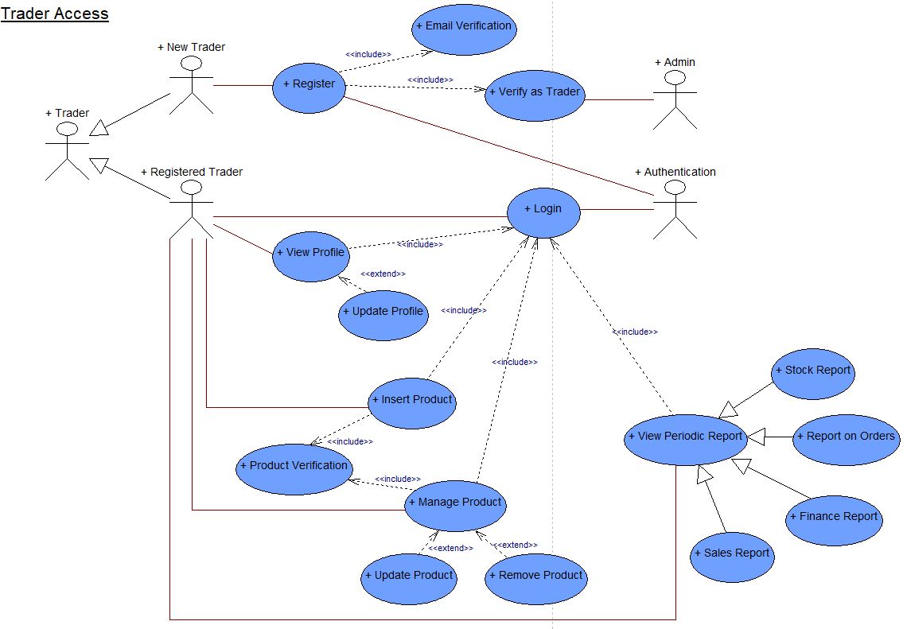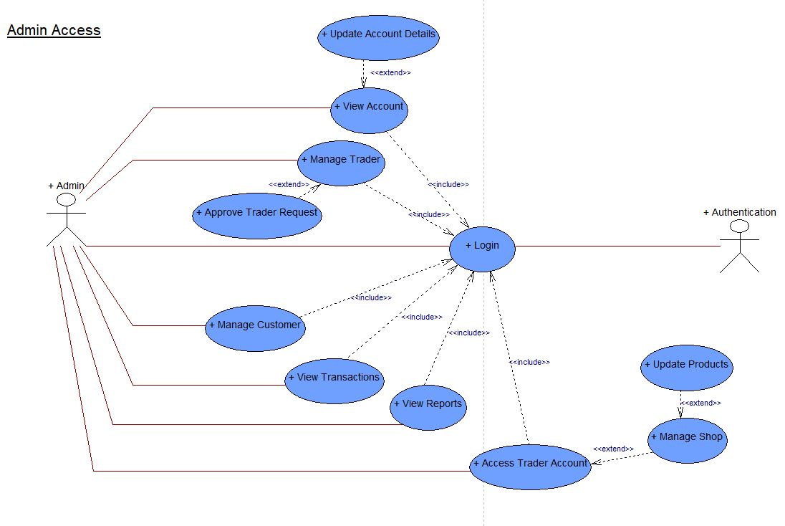

## Wireframes

### Homepage

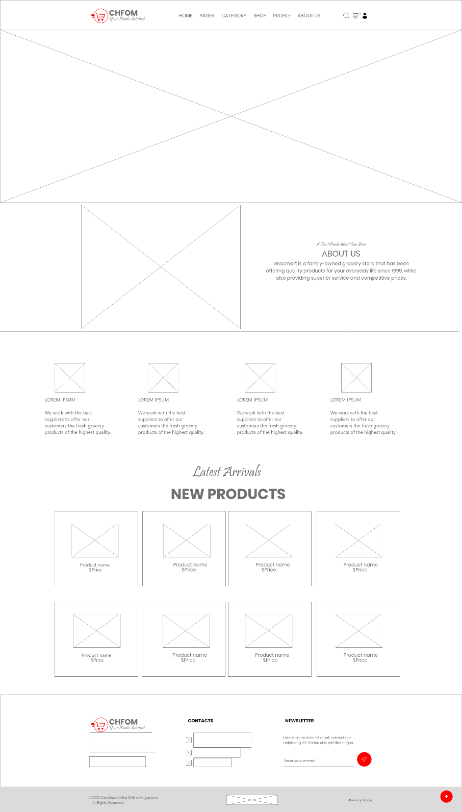

### About Us

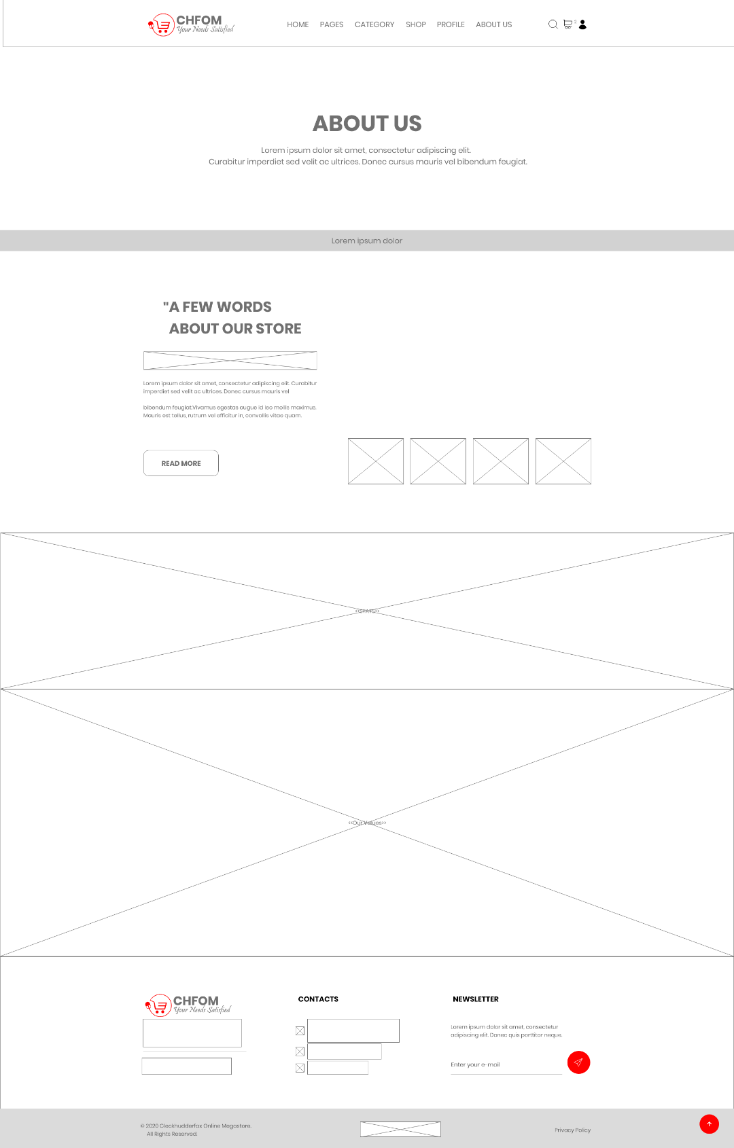

### Shop

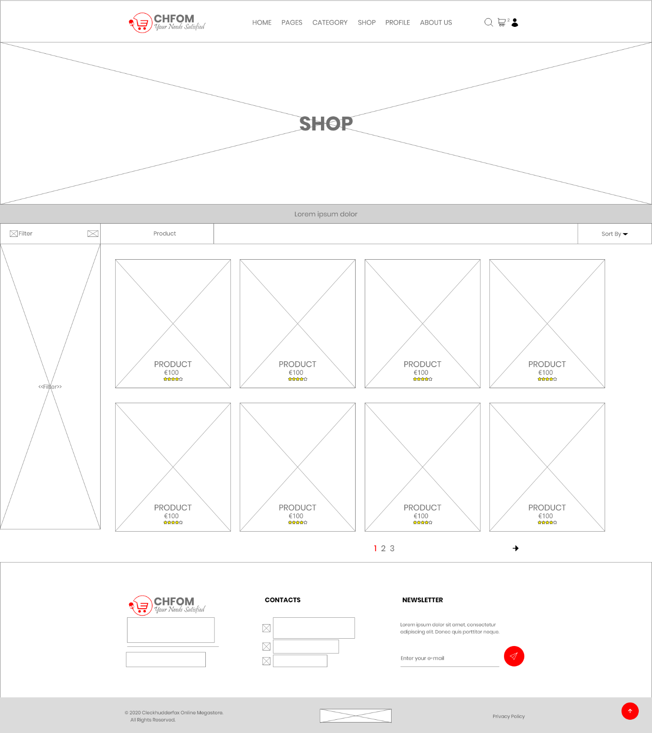

### Single Product Page

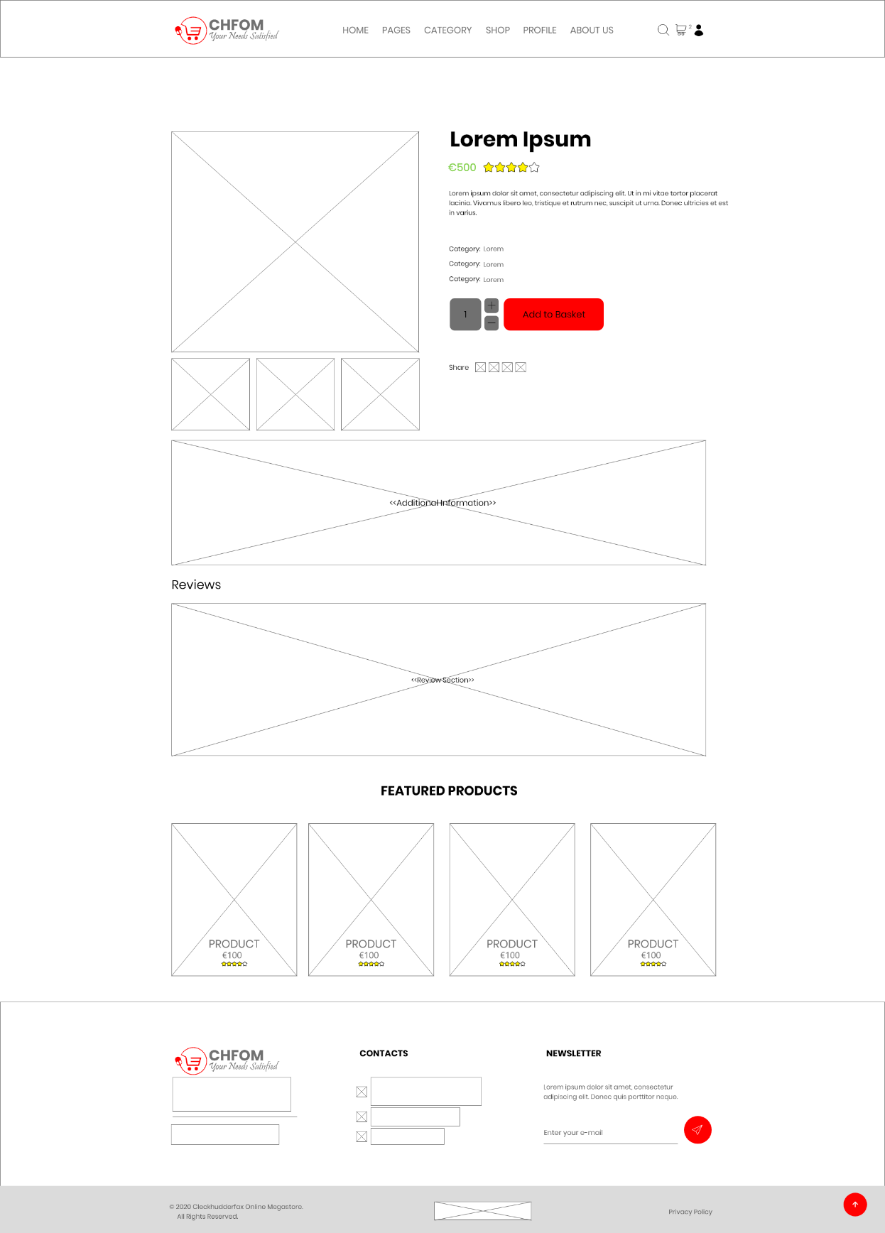

### Search

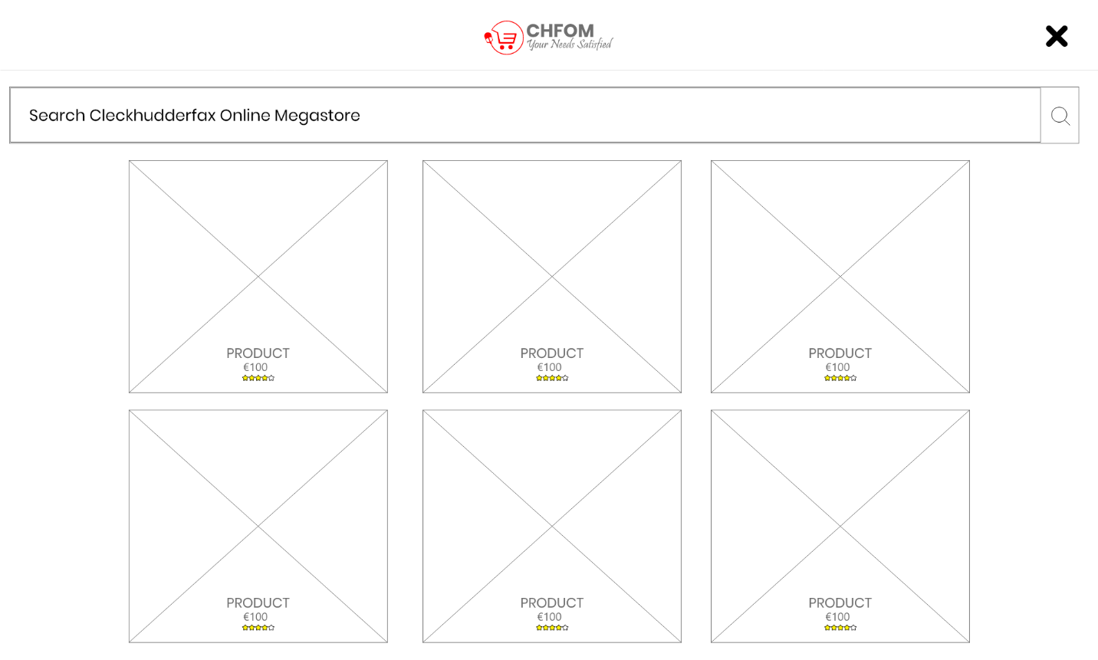

Login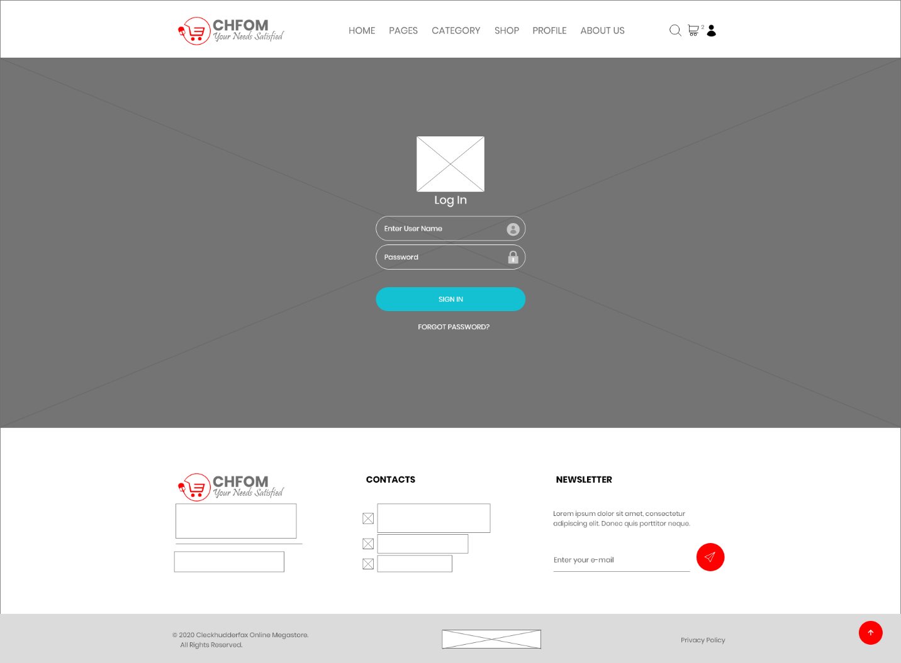

### Basket Overview

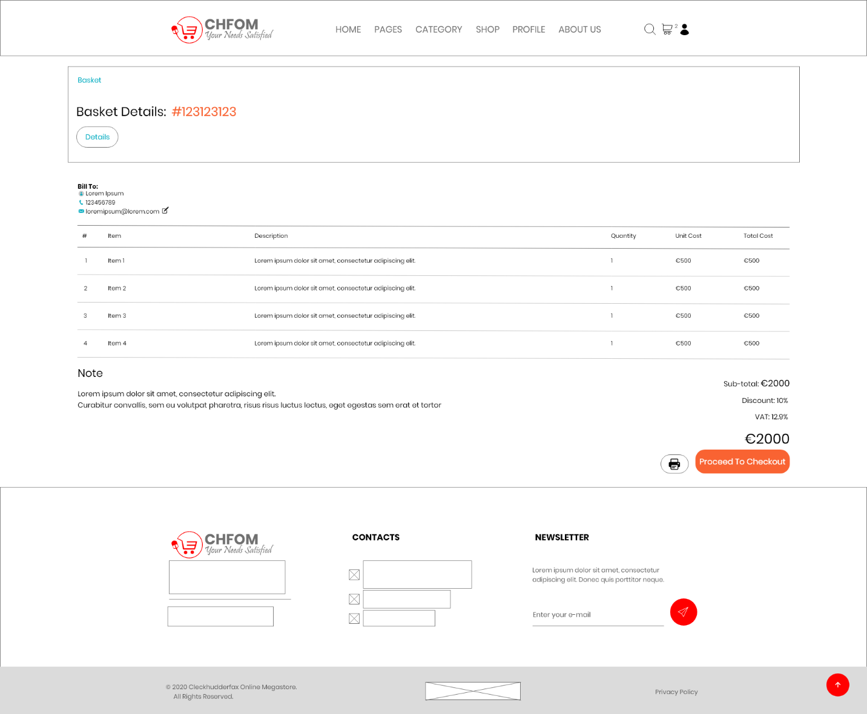

Customer Profile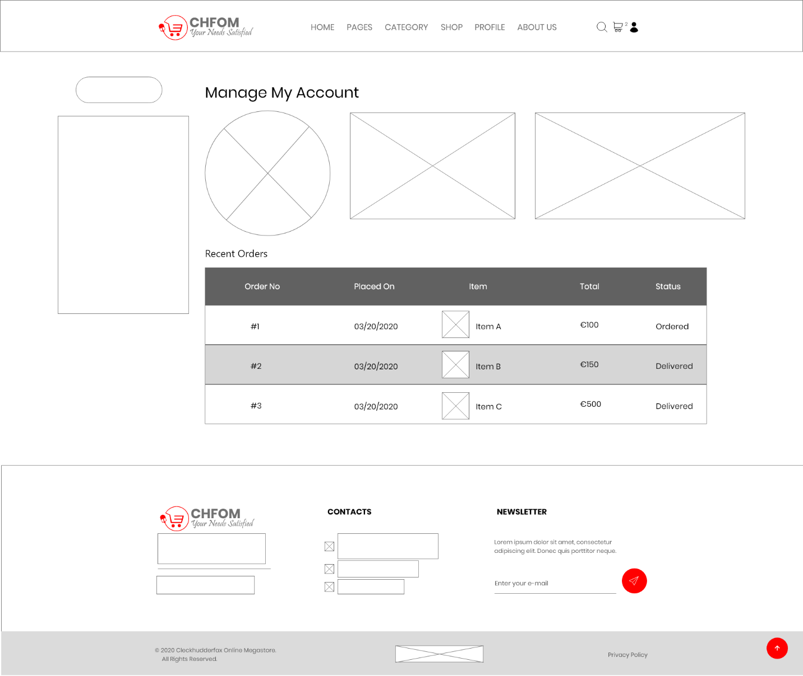

## Website Work in Progress

### Homepage

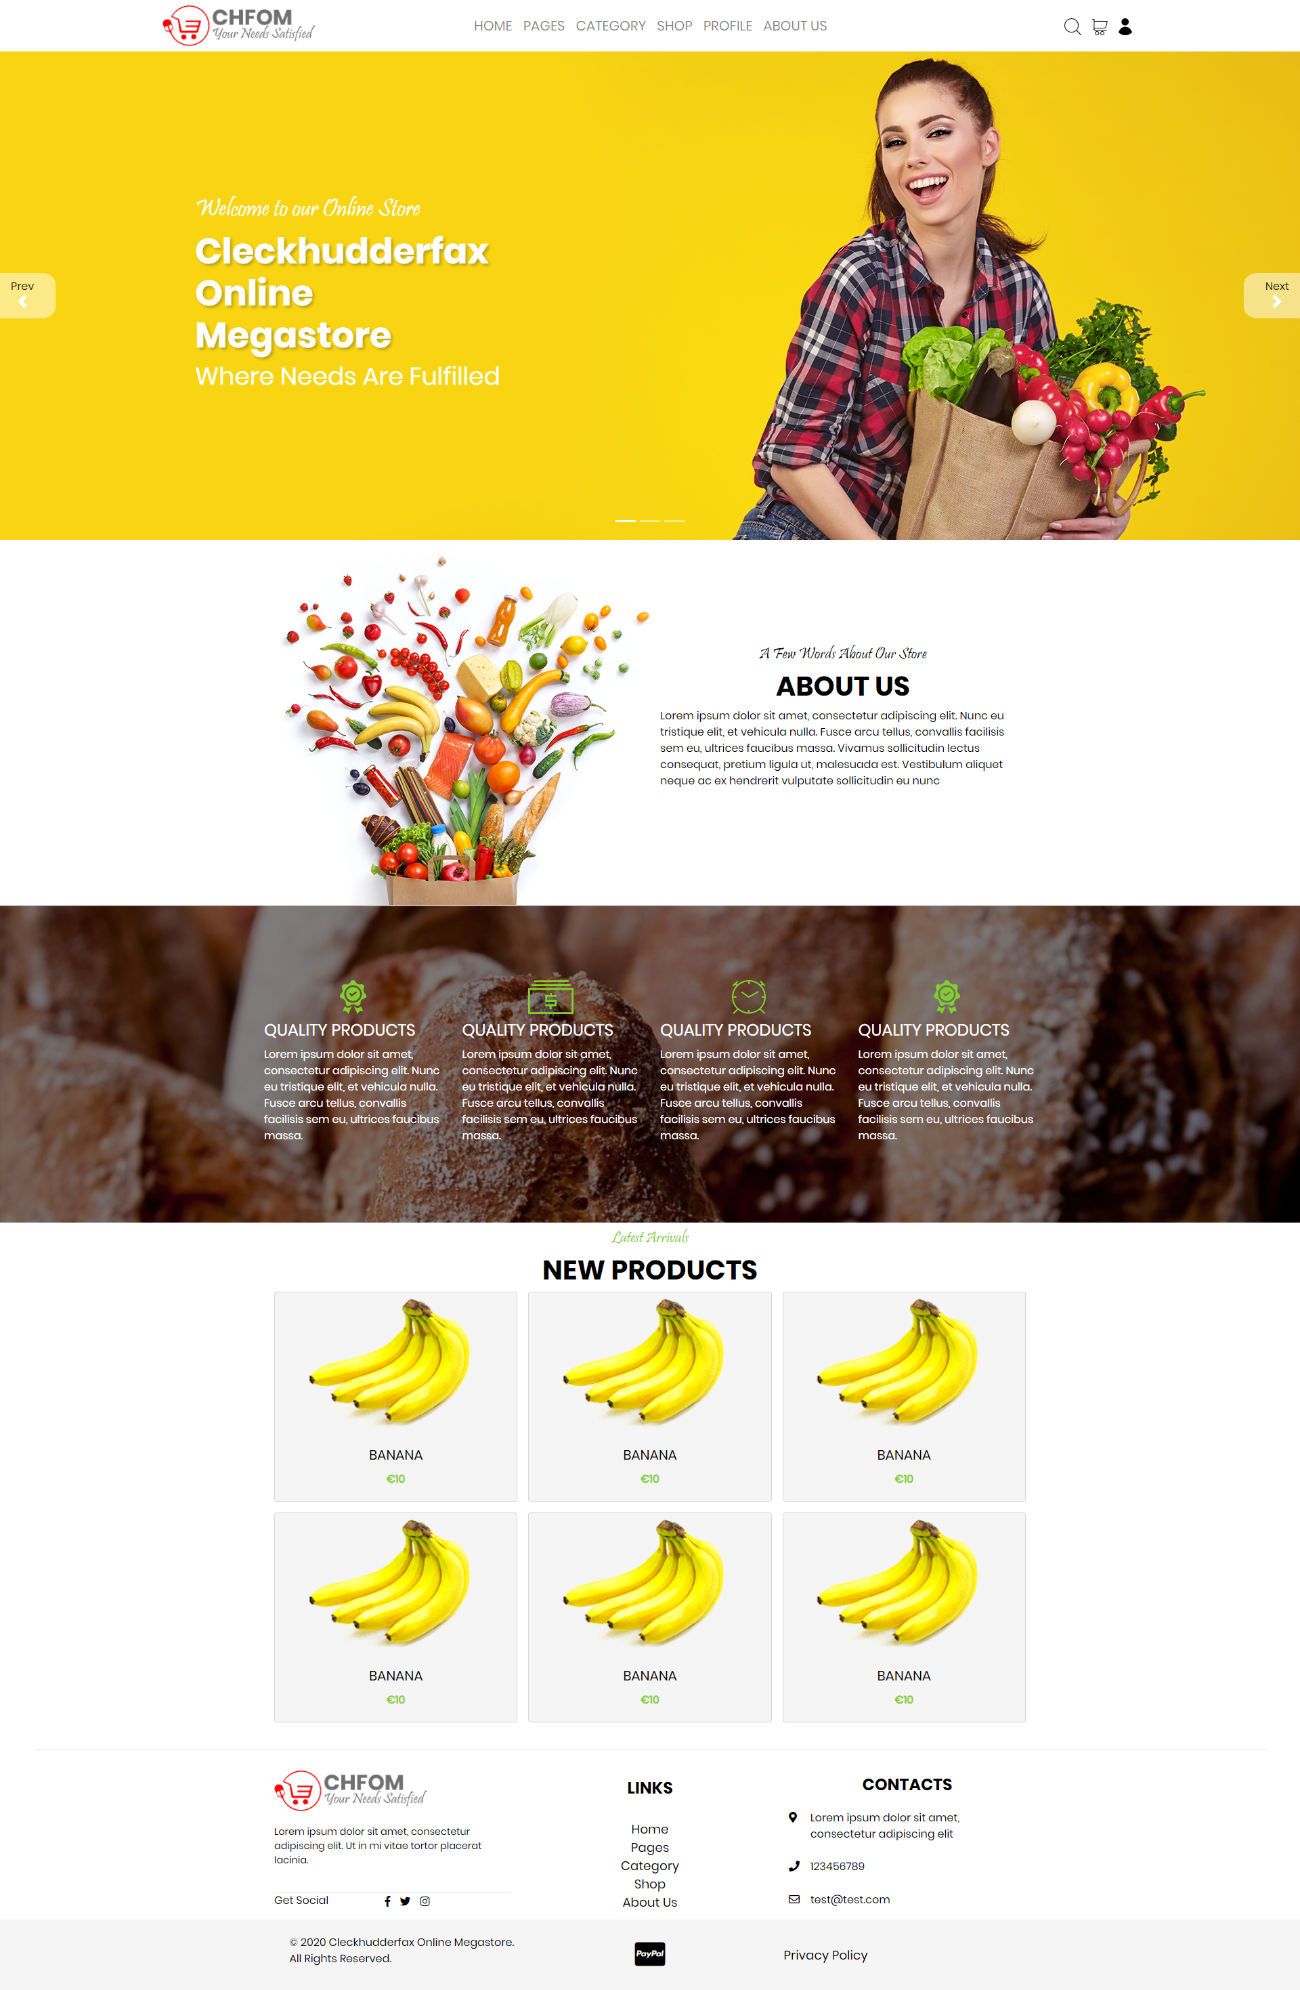

### Login

